Decomposers and the
Carbon Cycle
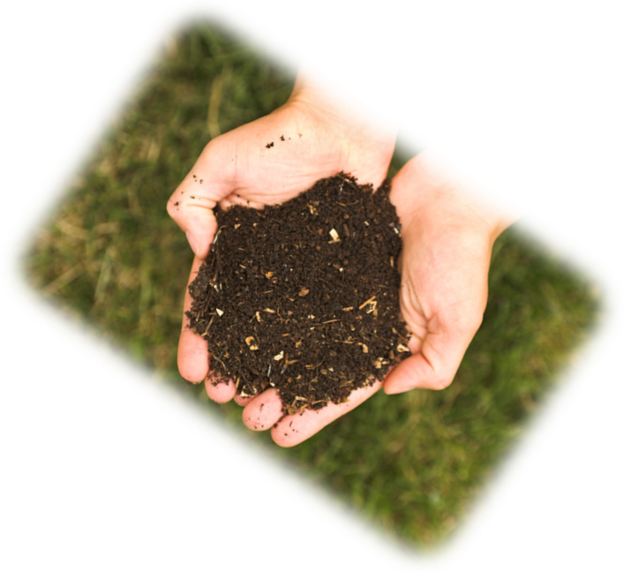

How decomposition changes
Carbon and chemical energy
The Environmental Literacy Project
2012-2013

Table of Contents
Table of Contents 2
Decomposers Unit Overview 3
Specifications for Decomposers Unit 6
Decomposers Unit At a Glance 7
Learning Objectives for Middle and High School Students 8
Timeline and Overview 10
Teaching Decomposers to Middle and High School Students 13
Additional Decomposers Unit Information 14
Vocabulary 14
Links to Videos 15
Materials 15
Acknowledgments 17
Unit Pre-Lesson: Bread Mold Investigation Set Up 18
Activity 1: Investigation Set Up 19
Bread Mold Investigation Procedures 20
Lesson 1: Pre-test and Discussion of What Happens to Materials When They Decay 21
Activity 1: Decomposers Unit Pre-Test 22
Decomposers Pretest and Posttest 23
Decomposers Pretest and Posttest with Commentary 25
Activity 2: Discussion of What Happens to Decaying Materials 28
Optional Lesson: What Makes Up Our Food? 30
Lesson 2: Bread Mold Investigation 30
Activity 1: Bread Mold: Initial Predictions and Explanations 32
The Three Questions: Explaining Matter and Energy in Combustion and Life 34
Bread Mold: Initial Predictions and Explanations Worksheet 35
Assessing Bread Mold: Initial Predictions and Explanations Worksheet 36
Activity 2: Bread Mold Observations and Explanations 37
Bread Mold: Observations and Explanations Worksheet 39
Grading Bread Mold: Observations and Explanations Worksheet 40
Lesson 3: Explaining How Decomposers Grow and Function 41
Activity 1: Explaining What Happens When Mushrooms Grow 44
Explaining What Happens When Fungi Grow 46
Grading Explaining What Happens When Fungi Grow Worksheet 47
Activity 2: Modeling Digestion and Biosynthesis in Fungi 47
Monomer Cards (Small Organic Molecules) 50
Polymer Cards (Large Organic Molecules) 51
Modeling Digestion and Biosynthesis 52
Grading Modeling Digestion and Biosynthesis 53
Activity 3: Cellular Respiration in Fungi 54
Explaining Cellular Respiration in Fungi 56
Grading Explaining Cellular Respiration in Fungi 57
Optional activity: Using Molecular Models to Explain Cellular Respiration 58
Optional Reading: What is Cellular Respiration? 58
Lesson 4: Other Examples of Decomposers 62
Optional Activity: Decomposers in the Soil 64
Finding Decomposers in the Soil 66
Activity 1: Explaining Other Examples of Decomposition 69
Other Examples of Decomposition Worksheet 71
Grading Other Examples of Decompostion Worksheet 73
Activity 2: Decomposers Unit Posttest 75
Grading the Decomposers unit Posttest 75

Decomposers Unit Overview
Decomposers is one in a series of six units (Systems and Scale, Animals, Plants, Decomposers, Ecosystems, Human Energy Systems) developed by the Carbon: Transformations in Matter, and Energy (Carbon TIME) Project. These six units can be used at the middle school or high school level. They are based on research focusing on learning progressions leading to environmental science literacy, described below. The purpose of these units is to enable students to uncover the chemical basis of life and lifestyles.
Key scientific ideas about carbon-transforming processes. The chemical basis of life and lifestyles lies in carbon-transforming processes in socio-ecological systems at multiple scales, including cellular and organismal metabolism, ecosystem energetics and carbon cycling, carbon sequestration, and combustion of fossil fuels. These processes: (a) create organic materials (photosynthesis), (b) transform organic materials (biosynthesis, digestion), and (c) oxidize organic materials (cellular respiration, combustion). We think that it is important for students to understand carbon-transforming processes for many reasons; among them: the primary cause of global climate change is the current worldwide imbalance among these processes.
The reason these processes are unbalanced lies in the nature of organic materials: foods, fuels, and biomass (the tissues of living and dead organisms). All organic materials contain carbon and hydrogen, and store chemical energy in their carbon-carbon and carbon-hydrogen bonds that can be released when those materials combine with oxygen.
Virtually all of the chemical energy on Earth is stored in organic materials, and we need that chemical energy to maintain our lifestyles, so we burn organic materials—especially fossil fuels. So understanding these process is essential for students to act as informed citizens—what we call environmental science literacy.
Describing student learning in terms of learning progression levels. We have found that in order to achieve our program goals, students must learn new knowledge and practices—the science content described above. Underlying those changes, however, is an even more fundamental kind of learning—what we refer to as mastering scientific discourse.
Our everyday accounts of carbon-transforming processes are based on force-dynamic discourse or reasoning. Force-dynamic reasoning construes the events of the world as caused by actors (including people, animals, plants, machines, and flames), each with its own purposes and abilities, or by natural tendencies of inanimate materials. In order to accomplish their purposes, the actors have needs or enablers that must be present. For example, force-dynamic reasoning explains the growth of a tree by identifying the actor (the tree), its purpose (to grow), and its needs (sunlight, water, air, and soil). Force-dynamic predictions involve identifying the most powerful actors and predicting that they will be able to overcome antagonists and achieve their purposes as long as their needs are met.
This approach to reasoning about socio-ecological processes contrasts sharply with principled scientific discourse, which construes the world as consisting of hierarchically organized systems at different scales. Rather than identifying the most powerful actors, scientific reasoning sees systems as constrained by fundamental laws or principles, which can be used to predict the course of events. Each of our learning progressions involves students learning to apply fundamental scientific principles to the phenomena of the world around them.
So it is useful to think of learning science as like learning a second language. Students at the beginning of the learning progression are monolingual: They have mastered force-dynamic discourse but know little of the nature and power of scientific discourse. So our goal is to help students become “bilingual,” able to use force-dynamic or scientific discourse as the occasion demands. This is a difficult goal in part because force-dynamic and scientific discourse often use the same words (e.g., energy, growth, food, nutrient, matter) with different meanings. The differences can remain hidden to both teachers and students, creating the appearance of common understanding while profound differences remain.
We define students’ progress toward mastering scientific knowledge, practices, and discourse in terms of four levels of achievement, ranging from Level 1 (completely dependent on force-dynamic discourse) to Level 4 (able to choose between force-dynamic and principled scientific accounts of carbon-transforming processes). Very briefly, the levels we have identified are as follows:
Level 1: Pure force-dynamic accounts: Students have no choice but to rely on force-dynamic discourse. Their accounts focus on actors, enablers, and natural tendencies of inanimate materials, using relatively short time frames and macroscopic scale phenomena.
Level 2: Elaborated force-dynamic accounts: Students’ accounts continue to focus on actors, enablers, and natural tendencies of inanimate materials, but they add detail and complexity, especially at larger and smaller scales. The include ideas about what is happening inside plants and animals when they grow and respond, for example, and they show awareness of larger scale connections among phenomena such as food chains and how decay enriches the soil.
Level 3: Incomplete or confused scientific accounts: Students show awareness of important scientific principles and of models at smaller and larger scales, such as cells, atoms and molecules, and cycling of gases and materials in ecosystems. They have difficulty, though, connecting accounts at different scales and applying principles consistently. In particular, they often confuse matter and energy and fail to account for the mass of gases in their accounts.
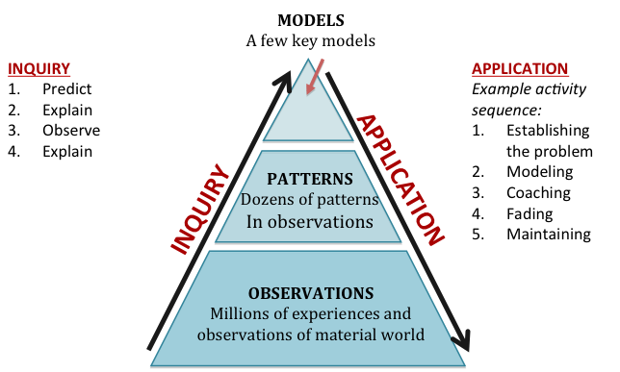
Level 4: Coherent scientific accounts: Students successfully apply fundamental principles such as conservation of matter and energy to phenomena at multiple scales in space and time. In general, our descriptions of Level 4 performances are consistent with current national science education standards and with the draft framework for new standards.
Purpose and structure of Carbon TIME units. Each of our six units (Systems and Scale, Animals, Plants, Decomposers, Ecosystems, Human Energy Systems) focuses on familiar systems and events that involve carbon-transforming processes. Each unit is designed to help students at Level 2 in the learning progression (the most common starting point for middle school and high school students) advance to Level 3 or Level 4.
All of the units focus on conservation of matter and energy as fundamental principles, and all follow a general instructional model (see figure) that engages students in both inquiry and application (accounts) practices. The investigations follow a PEOE (predict-explain-observe-explain) sequence. Teaching of application practices is based on a cognitive apprenticeship model: (a) students are put in situations where they can observe other people engaging in the activity—modeling, (b) the students engage in the practice with scaffolding or support from others—coaching, and (c) the support is gradually withdrawn until the students are independently engaged in the practice—fading.
Instructional model for teaching units
The central role of the Three Questions. We believe that we can help students move to higher levels in the learning progression most effectively by focusing both the inquiry and application sequences on Three Questions: the Movement Question, the Carbon Question, and the Energy Question. These questions along with rules that we will expect students to follow and evidence we will expect them to look for in answering them, are presented in Table 1 below.
Table 1: The Three Questions
Question | Rules to Follow | Evidence to Look For
The Movement Question: Where are atoms moving?  Where are atoms moving from?  Where are atoms going to? | Atoms last forever in combustion and living systems  All materials (solids, liquids, and gases) are made of atoms | When materials change mass, atoms are moving  When materials move, atoms are moving
The Carbon Question: What is happening to carbon atoms?  What molecules are carbon atoms in before the process?  How are the atoms rearranged into new molecules? | Carbon atoms are bound to other atoms in molecules  Atoms can be rearranged to make new molecules | The air has carbon atoms in CO₂  Organic materials are made of molecules with carbon atoms  - Foods  - Fuels  - Living and dead plants and animals
The Energy Question: What is happening to chemical energy?  What forms of energy are involved?  How is energy changing from one form to another? | Energy lasts forever in combustion and living systems  C-C and C-H bonds have more stored chemical energy than C-O and H-O bonds | We can observe indicators of different forms of energy  - Organic materials with chemical energy  - Light  - Heat energy  - Motion

Comments on goals based on the Three Questions. Our focus on the Three Questions arises from our reading of the data from the first pilot tests of our units during the 2011-12 school year, as well as our reading of data from other projects (e.g., Jin & Anderson, in press). We are convinced that our first priority for student learning should be to engender a sense of necessity about conservation of matter and energy, along with the ability to apply these principles to carbon-transforming processes.
The essential understandings that students should have from Systems and Scale are summarized in the three columns of the Three Questions Poster—Table 1 above, which is available as a wall poster and as a handout for Lesson 1 Activity 2 in this unit. Each of the three columns in this poster is important:
- The Movement Question, the Carbon Question, and the Energy Question. Students should understand that a good explanation of a process such as decomposition of a tree includes answers to each of these questions. Note that each question focuses on a different aspect of the process:
  - The Movement Question focuses on physical movements of materials.
  - The Carbon Question focuses on chemical change—atoms being rearranged into new molecules.
  - The Energy Question focuses on transformation of energy.
- Rules to Follow. Students should understand that the matter and energy conservation laws are never broken in chemical and physical changes: Atoms last forever and energy lasts forever.
- Evidence to Look For. Students should understand that evidence from investigations can inform them about answers to the three questions. In particular:
  - Mass changes can tell about answers to the Movement Question because the mass of a system can change ONLY if atoms move in or out of the system.
  - Changes in the color of BTB can help to answer the Carbon Question by showing what is happening to carbon dioxide
  - Energy indicators can help them identify the four forms of energy discussed in this unit: light, chemical energy in organic molecules, heat, and work/motion.

Specifications for Decomposers Unit
Decomposers builds on student learning in Systems and Scale about organic and inorganic materials, how all systems exist at multiple scales, and transformation of materials and energy during chemical change. In Animals students learn how the processes of digestion and biosynthesis transform food molecules into the biomass of an organism during growth, and how the process of cellular respiration transforms organic materials to inorganic materials and chemical energy to energy for function and movement of organisms.
For students who have studied Plants and Animals, the most important idea to learn from the Decomposers unit is this: The answers to the Carbon Question and the Energy Question are essentially the same for animals and decomposers. Animals and decomposers are both heterotrophs—they rely on biomass from other sources for their matter and energy. This makes them fundamentally different from plants and other autotrophs—organisms that can use sunlight as an energy source and make organic molecules—food or biomass—from inorganic matter.
Our work on learning progressions shows that this will be a surprising conclusion for Level 2 and Level 3 students, who view decay as an entirely different process from animals eating and moving. For example, Level 2 students tend to view processes in terms of how “active” or “capable” the “actors” are:
- Animals are the most active actors, capable of eating, moving, growing, thinking, etc.
- Plants are not as active as animals, but still capable of some important life processes, such as growth and limited movement.
- Decay is what happens when living things have lost the energy of life; it is an inevitable recycling process that accompanies death. (If Level 2 students recognize a role for decomposers at all it is as “helpers” in the decay and recycling process.)
Thus what successful students need to learn from the Decomposers unit is how much they actually already understand about decomposers:
- The answers to the Movement Question are different for decomposers and animals: Decomposers digest food outside their bodies, then move small organic molecules through their bodies for biosynthesis (growth) and cellular respiration (energy for growth and functioning).
- They already know the answers to the Carbon Question and the Energy Question from studying Animals. So in this unit they just need to learn how to apply their knowledge to different organisms that are a lot more like animals than they thought!

Decomposers Unit At a Glance

Lesson or Activity | Time Estimate
Unit Pre-Lesson: Bread Mold Investigation Set Up
Activity 1: Investigation Set Up | 30 min
Lesson 1: Pre-test and Discussion of What Happens to Materials When They Decay
Activity 1: Decomposers Unit Pre-Test | 20 min
Activity 2: Discussion of What Happens to Decaying Materials | 25 min
Lesson 2: Bread Mold Investigation
Activity 1: Initial Bread Mold Explanations and Predictions | 30 min
Activity 2: Bread Mold Observations and Explanations | 60 min
Lesson 3: Explaining How Decomposers Grow and Function
Activity 1: Explaining What Happens When Mushrooms Grow | 25 min
Activity 2: Modeling Digestion and Biosynthesis in Fungi | 50 min
Activity 3: Cellular Respiration in Fungi | 50 min
Optional Activity: Using Molecule Models to Explain Cellular Respiration | 60 min
Lesson 4: Other Examples of Decomposers
Optional Activity: Decomposers in the Soil | 10-90 min
Activity 1: Explaining Other Examples of Decomposition | 45 min
Activity 2: Decomposers Unit Post-Test | 20 min

Learning Objectives for Middle and High School Students
The table below lists the key goals for student learning in terms of inquiry and application practices and the challenges that those goals pose for Level 2 students (including most middle school students and many high school students and Level 3 students (including some high school students). Note the organization of the table:
- There are three types of inquiry goals, focusing on measurement, using investigations to construct arguments from evidence, and collective validation of results of investigations.
- There are three types of application goals, focusing on the Three Questions: the Movement Question (physical movement of materials), the Carbon Question (chemical change), and the Energy Question (transformations in forms of energy).
Type of Objective | Learning Objective | Challenges for Level 2 Students | Challenges for Level 3 Students
Inquiry: Measurement | Measure mass changes in decaying bread and other materials.  Detect changes in CO₂ concentration in chambers with decaying materials. | Level 2 students may have trouble reading digital balances and attaching meaning to measurements in small fractions of grams.  Level 2 students will not think of air as a mixture of different gases, so while they can understand that BTB detects CO₂, they will not think of CO₂ as one of the mix of gases in the air. | Level 3 students may have trouble accounting for tare weight and interpreting small fluctuations in readings on digital balances. They will have difficulty identifying threats to accuracy and precision in measurement.
Inquiry: Arguments from evidence | Construct arguments that use evidence about changes in mass of decaying materials and CO₂ concentration to defend claims about movements of atoms and chemical changes during decay. | Level 2 students will not interpret changes in mass as evidence of movements of atoms, believing instead that materials “break down” or are destroyed when they decay. Level 2 students are also likely to be unaware that gases are involved in the decay process. | Level 3 students will see the relevance of evidence to claims, but they will not systematically consider alternate hypotheses or show how evidence supports or refutes specific claims.
Inquiry: Collective validation | Find patterns in data collected by multiple groups about changes in mass of decaying materials and CO₂ concentration. | Level 2 students may focus primarily on their own results rather than seeing the value of multiple measurements. | Level 3 students will understand that multiple measurements are valuable, but they will have few strategies for finding patterns across multiple trials.
Application: Movement question | Describe systems and processes in fungi in a hierarchy of scales, including atomic-molecular and macroscopic scales.  Draw and explain movements of materials during decay processes. | Level 2 students will explain decay as a natural process in which dead things disappear or are recycled. They will not interpret weight loss as evidence that atoms are moving. | Level 3 students will recognize that materials are moving during decay, but they are likely to leave CO₂, in particular, out of their accounts.
Application: Carbon question | Identify the most abundant organic materials in decaying matter, including proteins and carbohydrates, and use food labels to find out how concentrated they are in different foods and animal tissues.  Explain the chemical changes that occur during decay, including materials being incorporated into biomass of decomposers and cellular respiration, representing the changes with molecular models and chemical equations. | Level 2 students will explain what happens as a natural process (the decaying material breaks down or is recycled) rather than as a chemical change in which atoms and mass are conserved. They may recognize that decomposers are involved, but they will not consider decaying materials to be food sources for the decomposers. | Level 3 students will recognize that a chemical change is taking place, but they will not be able to successfully trace all the materials through the decay process. They may say that the decaying matter is converted to energy or that all the matter is recycled through the soil.
Application: Energy question | Identify forms of energy involved in decay: chemical energy, movement, and heat energy.  Explain energy transformations during decay processes. In particular, chemical energy stored in C-C and C-H bonds of organic molecules is used to support life processes in decomposers and ultimately converted to heat. | Level 2 students will recognize that living organisms have energy, but may associate that energy with vitality (dead organisms have no energy) rather than with organic materials.  Level 2 students will not be committed to conservation of energy—the idea that decay processes MUST produce heat. | Level 3 students are likely to dead things as energy sources for animals, but they may not consider the same materials to be energy sources for decomposers.

Timeline and Overview
The table below summarizes the sequence of unit activities, showing how they address the inquiry and application goals and how they fit into the instructional model for the unit.
Structure and Sequence | Guiding Question | Activity Description | Learning Objectives | Background Information
Lesson 1: Pre-test and discussion of what happens to materials when they decay
Guiding Question: What happens to materials when they decay
Lesson Description: In this lesson students take a pre-test and then share their initial ideas about what happens to materials when they decay.
Activity 1: Unit Pretest  20 min | How do students understand decay and decomposition? | Students complete a pretest assessing their understanding of decay and decomposition. | Students will express their initial ideas about what happens to materials when they decay during the pre-test | This is a formative assessment activity. You can track students’ progress by having them retake the unit pre-test as a post-test at the end of the unit and comparing the results of the two assessments.
Activity 2: What happens to decaying materials?  25 min | What happens to decaying materials? | As students participate in this unit, they will collect evidence and develop explanations about decomposers and how they decay materials. This activity begins by eliciting students’ prior knowledge about what happens to decaying materials. | Students will share and record the classes’ initial ideas about what happens to decaying materials | Most students cannot explain that food is the main contributor to the mass of a decomposer, or how food gets broken down and reassembled as the body of a decomposer. Most students also do not associate food or decaying materials with the carbon dioxide that they breathe out. They know that food or decaying materials is “burned up” to provide energy, but they do not distinguish the “breaking down” of digestion from the “breaking down” of cellular respiration. Many students often believe that food or decaying materials is converted to energy.
Lesson 2: Bread Mold Investigation
Guiding Question: What happens when materials decay?
Lesson Description: Students make specific predictions about what they will observe and why. They discuss the Three Question as ways to explain chemical changes. Finally, they compare results when they use digital balances and bromothymol blue (BTB) to measure changes in matter.
Activity 1: Predict and Explain (PE) in Inquiry Sequence 30 min | How can we predict and measure changes in mass and CO2 concentrations while bread molds? | Students make predictions for the bread mold investigation to measure mass changes in decaying materials.. Students make predictions and explain those predictions. Students are able to make predictions about mass changes in decaying materials and to provide evidence for investigation | Students will measure mass changes and detect changes in CO2 concentration in decaying materials.  Students will also construct arguments using evidence from the investigation. | Students can make predictions about decaying materials that will help them answer the Three Questions. In class observations are at a macroscopic level, limiting students to information about mass changes, carbon dioxide increasing or decreasing in the air around the decaying materials, and only some forms of energy (light, motion and sometimes heat). The observations that students make of the system will relate to all three processes of digestion, biosynthesis and cellular respiration. After this lesson, students practice explaining processes of digestion and biosynthesis separately from cellular respiration.
Activity 2: Bread Mold Observations and Explanations  60 min | What do we observe about changes in mass and CO2 concentration when bread molds? | Students work in groups of 4 to make and record observations of mass change in the decaying materials, as well as BTB color change. They compare their observations with other groups in the class and with other classes, reaching conclusions about patterns in the observations, suggest explanations, and note unanswered questions. | Students measure mass changes and detect changes in CO2 concentration Students also find patterns in data and construct arguments based on experimental evidence. | The observations that students make of the system will relate to all three processes of digestion, biosynthesis and cellular respiration. After this lesson, students practice explaining processes of digestion and biosynthesis separately from cellular respiration.  Student inquiry practices include making measurements, making claims based on evidence, and coming to consensus on results by finding patterns in sets of data.
Lesson 3: Explaining How Decomposers Grow and Function
Guiding Question: How do mushrooms grow and function?
Lesson Description: Students will begin to describe systems using the atomic-molecular and macroscopic scales. Using food labels, students learn that the biomass of living things is actually carbohydrates, fats, and proteins similar to those things found in food. Students model cellular respiration to see that organic materials with chemical energy are changed into inorganic water and carbon dioxide. The lesson concludes with a final explanation of movement and cellular respiration using the Three Questions.
Activity 1: Explaining What Happens When Mushrooms Grow  25 min | How do mushrooms grow? | Using the results from the bread mold investigation students will compare how fungi compare to plants and animals. This comparison will be made using the data about mass changes and CO2 concentration. Students will work with the movement and carbon questions by looking at a food label and determining what organic materials would be in fungus. | Students describe systems and processes in fungi in a hierarchy of scales, including atomic-molecular and macroscopic scales. Students also identify the most abundant organic materials in decaying matter, including proteins and carbohydrates, and use food labels to find out how concentrated they are in different foods and animal tissues. | Growing is the macroscopic manifestation of two carbon-transforming processes: digestion and biosynthesis. Since Fungi break down polymers outside their bodies during digestion atoms are moving from food to the decomposer’s hyphae cells and through the mycelium. The cells in the hyphae send out digestive enzymes that break the polymer into monomers (small organic molecules). The small monomers then can enter the cells of the hyphae and travel through the mycelium.
Activity 2: Modeling Digestion and Biosynthesis in Fungi  50 min | How do mushrooms grow? | In this activity students use paperclips to model the breakdown (digestion) and rebuilding (biosynthesis) of key polymers ingested when decomposers decay materials. During the activity, students place monomers and polymers on a poster of a mushroom to represent where these processes are occurring in the mushroom. | Students will describe systems and processes in fungi in an atomic-molecular and macroscopic scale. They will also draw and explain movements as well as explain the chemical changes of materials during decay. | The Movement Question for biosynthesis can be answered as atoms are moving from the hyphae to the mycelium. The Carbon Question for digestion can be answered as organic carbon in polymers are rearranged into monomers. The Carbon Question for biosynthesis can be answered as organic carbon in monomers is again rearranged into polymers. The Energy Question for both digestion and biosynthesis is that all of food polymers, monomers and biomass polymers have chemical energy.
Activity 3: Cellular Respiration in Fungi  40 min | How do cells in fungi get their energy? | Students use a mushroom model to draw and explain the movement of materials during decay. Students explain the chemical changes that occur during decomposition by verbally describing the process and writing a balanced equation. Using the Three Questions, students explain energy transformations during the decay process. | Students will draw and explain the movement of materials during decay. They will explain the chemical changes, and the energy transformations that occur during decay. Students will also identify the forms of energy involved in decay. | Fungi obtain the energy they need to function through the rearrangement of atoms during metabolic processes. This is the sole purpose of cellular respiration in all living organisms. Every living organism, from the smallest bacteria to the largest tree in the forest, needs to acquire a source of chemical energy, which is found in organic matter. Once organic matter is oxidized, the chemical energy found in the high-energy bonds is transformed into chemical energy in other high energy bonds (in ATP), then ultimately into kinetic energy and heat.
Optional Activity: Using Molecular Models to Explain Cellular Respiration  20 min | How are atoms rearranged into new molecules during cellular respiration? | Students explain the patterns of results in terms of a chemical change: the reaction of food or biomass and oxygen to produce carbon dioxide and water. They practice describing the chemical change in three different ways: using molecular models, a chemical equation, and the Process Tool. | Students will draw and explain the movement of materials during decay. They will explain the chemical changes, and the energy transformations that occur during decay. Students will also identify the forms of energy involved in decay. | See Lesson 5, Activity 2 in the Animals unit.
Lesson 4: Other Examples of Decomposers
Guiding Question: How do decomposers live and grow in other places?
Lesson Description: Students finish the application sequence with the fading stage, by practicing explanations of digestion, biosynthesis and cellular respiration for other decomposers. Students retake the pretest that they took at the beginning of the unit and assess what they have learned.
Optional Activity: Decomposers in the Soil  10-90 min | How do decomposers live and grow in other places? | In this optional activity students have the opportunity to explore evidence of decomposers in soil in several different ways: a National Geographic podcast, a brief reading on decomposition of trees in the forest, and laboratory activities focusing on three different ways to find evidence of decomposers in the soil. | Students will describe systems and processes in fungi in a hierarchy of scales. Students will draw and explain movements of materials during decay processes. They will also explain the chemical changes that occur during decay. | Fungi break down polymers outside their bodies, the Movement Question for digestion can be answered as atoms are moving from food to the decomposer’s hyphae cells and through the mycelium. The cells in the hyphae send out digestive enzymes that break the polymer into monomers (small organic molecules). The small monomers then can enter the cells of the hyphae and travel through the mycelium. The Movement, Carbon, and Energy Question can be answered
Activity 1: Explaining Other Examples of Decomposition  45 min | How decomposers live and grow in other places? | In this activity, students choose—or you choose for them—two other examples of decomposition. Students then use the forms and procedures they used for bread mold and mushrooms to explain the carbon transforming process. | Students will describe systems and processes in decomposers. Students will draw and explain movements of materials during decay. They will identify the most abundant organic materials in decaying matter. They will explain and identify the chemical changes that occur during decay. Students will explain energy transformations during decay processes. | This activity is the Fading stage of the accounts activity cycle for digestion, biosynthesis and cellular respiration. It serves as summative assessment for you—you will be able to see how well they understood the bread mold and mushroom examples—and gives students additional practice explaining examples with less support than they had for bread mold and mushrooms.
Activity 2: Decomposers Unit Post-Test  20 min | What have students learned about decomposers and the process of decomposition? | In this activity, students retake the pretest that they took at the beginning of the unit and assess what they have learned. | Students will take a test that assesses most key learning objectives for the unit. | The Post-test is a summative assessment activity. You can track students’ progress by having them retake the unit pre-test as a post-test and comparing the results of the two assessments.

Teaching Decomposers to Middle and High School Students
Decomposers is designed for students who have completed the Systems and Scale unit. We also recommend that students complete the Animals before Decomposers, but the activities of this unit are designed to be meaningful to students who have not completed Animals. The majority of students in most middle school and high school classes start at Level 2. As discussed above in the introduction to the Specifications for the Decomposers Unit, what successful students need to learn from the Decomposers unit is how much they actually already understand about decomposers:
- The answers to the Movement Question are different for decomposers and animals: Decomposers digest food outside their bodies, then move small organic molecules through their bodies for biosynthesis (growth) and cellular respiration (energy for growth and functioning).
- They already know the answers to the Carbon Question and the Energy Question from studying Animals. So in this unit they just need to learn how to apply their knowledge to different organisms that are a lot more like animals than they thought!

If you have middle school students or if most of your students are starting at Level 2, then some activities may go into more detail than you wish. In particular, you may not want to go into the details of constructing cellulose and protein polymers, digesting them into monomers outside of fungus hyphae, and then constructing polymers again inside mushroom cells (Lesson 3 Activity 2). As an alternative, you can use the large molecule cards and focus on helping students understand the general processes of digestion and biosynthesis:
- Large organic molecules are digested into small organic molecules outside fungus hyphae by digestive enzymes that the fungus cells secrete.
- The small organic molecules enter the fungus cells and travel to all parts of the fungus.
- The small organic molecules are recombined into large organic molecules when cells grow and divide.

If you have high school students, particularly if the students in your class have studied the Animals unit, you may be able to do some lessons as review activities. Students who have studied the Animals unit should recognize that decomposers are like animals in many respects with the main difference (at the level of detail in this unit) being the answer to the Movement Question: Fungi and bacteria digest food outside their bodies while animals consume their food before digesting it. If your students understand this--AND understand the processes of digestion, biosynthesis, and cellular respiration in animals and plants--then you could focus on these main points rather than doing all of Lesson 3, Activities 2 and 3.

The optional activities in Lessons 2 and 3 are review activities that should not be necessary if students have already done these activities in the Animals unit. The optional activity at the beginning of Lesson 4 is an enrichment activity, providing students with several different opportunities to explore decomposers in the soil and to find evidence that they are engaging in cellular respiration.

Additional Decomposers Unit Information

Targeted Grades: 6-12

Key Concepts: Biosynthesis, Chemical Energy, Cellular Respiration, Decomposition, Digestion

Vocabulary
- Biomass
- Biosynthesis
- Building Blocks
- Carbon Dioxide
- Chemical Energy
- Cellular Respiration
- Decomposer
- Digestion
- Fungi
- Glucose
- Hyphae
- Inorganic Matter
- Mass
- Molecule
- Monomer
- Mushroom
- Mycelium
- Organic Matter
- Polymer
- Process

Links to Videos

National Geographic Podcast from Encyclopedia of Life

http://education.nationalgeographic.com/education/multimedia/fungi/?ar_a=1

Time-lapse video options:

This gallery from Cornell Plant Pathology contains time lapse movies of fungi, molds, bacteria, slime molds and insects of interest to plant pathologists: http://www.plantpath.cornell.edu/PhotoLab/timelapse.html. We recommend the strawberries or the bagel for this initial discussion, but you may want to return to the mushrooms later in the unit.

http://www.youtube.com/watch?v=Yv0p_JNYSgc
http://www.youtube.com/watch?v=msFWsPWfd6Q

YouTube videos might be useful for showing different decomposers:
http://www.youtube.com/watch?v=4csB8VRz-cQ&NR=1

Fungi Growth Videos:
http://www.youtube.com/watch?v=SGQBgPbzums&feature=fvsr
http://www.youtube.com/watch?v=0VXdco-WzNA&feature=relmfu

Bacteria Growth Videos:
http://www.youtube.com/watch?v=y3TOZ_abECM
http://www.youtube.com/watch?v=eqrtNef7w38

General Decomposition video (turn narrator off or on):
http://www.youtube.com/watch?v=5kG18FYISaY

Spontaneous combustion in hay:
http://www.youtube.com/watch?v=zRNCrHqD0zE

Materials

Lesson 1, Activity 1: Unit Pre-test
- Decomposers Unit Pre- and Post-test per student

For Lesson 1, Activity 2: What happens to decaying materials?
- Time Lapse Movies: This gallery from Cornell Plant Pathology contains time lapse movies of fungi, molds, bacteria, slime molds and insects of interest to plant pathologists: http://www.plantpath.cornell.edu/PhotoLab/timelapse.html. We recommend the strawberries or the bagel for this initial discussion, but you may want to return to the mushrooms later in the unit. See the preface for other video options.
- What happens to decaying materials? poster (24x36) (in DecomposersPosters.pptx) and Post-it notes per pair of students (Option 1), OR
PowerPoint Slide 2 in Lesson 1,3 Decay.pptx (Option 2)

For Lesson 2, Activity 1: Bread Mold Explanations and Predictions
- Lesson1,2Decay.pptx slides 5-7
- The poster and Post-it notes used to share ideas in Lesson 1: What Happens to Materials When They Decay? poster (11 x 17) OR Lesson1,2Decay.pptx slide 2 with ideas recorded
- Initial Predictions and Explanations worksheet per student

For Lesson 2, Activity 2: Bread Mold Observations and Explanations
- Lesson 1,2 Decay.pptx slides 10-16
- Materials for bread mold investigation: per group of 4 students
One digital balance
A large air-tight Ziplock container
Bromothymol blue (BTB) solution to detect CO₂ in the air inside the container
One plastic Petri dish for BTB
4 covered Petri dishes with molding bread (1 per student)
- Bread Mold Investigation Set up Checklist and Data Table (from the pre-lesson) per student
- Bread Mold: Observations and Explanations worksheet per student
- Decomposers Class Results.xlsx Excel file. Use the “Bread Mold Lesson 2” tab
- Class Results for Bread Mold Investigation poster (11 x 17)

For Lesson 3 Activity 1: Explaining What Happens When Mushrooms Grow
- Optional videos and multimedia
  - National Geographic Podcast from Encyclopedia of Life: http://education.nationalgeographic.com/education/multimedia/fungi/?ar_a=1
  - Time-lapse videos from Cornell Plant Pathology contains time lapse movies of fungi, molds, bacteria, slime molds and insects of interest to plant pathologists: http://www.plantpath.cornell.edu/PhotoLab/timelapse.html. We recommend the strawberries or the bagel for this initial discussion, but you may want to return to the mushrooms later in the unit.
    - http://www.youtube.com/watch?v=Yv0p_JNYSgc
    - http://www.youtube.com/watch?v=msFWsPWfd6Q
  - YouTube videos might be useful for showing different decomposers:
    - http://www.youtube.com/watch?v=4csB8VRz-cQ&NR=1
  - Fungi Growth Videos:
    - http://www.youtube.com/watch?v=SGQBgPbzums&feature=fvsr
    - http://www.youtube.com/watch?v=0VXdco-WzNA&feature=relmfu
  - Bacteria Growth Videos:
    - http://www.youtube.com/watch?v=y3TOZ_abECM
    - http://www.youtube.com/watch?v=eqrtNef7w38
  - General Decomposition video (turn narrator off or on):
    - http://www.youtube.com/watch?v=5kG18FYISaY
- Lesson 3 Explaining Fungi.pptx slides 1 - 9
- Explaining What Happens When Mushrooms Grow Worksheet per student

For Lesson 3 Activity 2: Modeling Digestion and Biosynthesis in Fungi
- Lesson 3 Explaining Fungi.pptx slides 10-26
- Modeling Digestion and Biosynthesis Worksheet per student
- Mushroom Poster (11 x 17), per pair of students
- Paper clips, 20 per pair of students
- Monomer Cards, cut into pieces, one sheet per pair of students
- Polymer Cards, cut into pieces, one sheet per pair of students (optional, recommended for middle school)

For Lesson 3 Activity 3: Cellular Respiration in Fungi
- Lesson 3 Explaining Fungi.pptx slides 27-33
- Explaining Cellular Respiration in Fungi worksheet per student

For Optional Activity: Modeling Cellular Respiration
- See materials list for Lesson 5, Activity 2 in the Animals unit: Using Molecular Models to Explain Cellular Respiration

For Lesson 4 Optional Activity: Decomposers in the Soil
- National Geographic Podcast from Encyclopedia of Life: http://education.nationalgeographic.com/education/multimedia/fungi/?ar_a=1
- Forest of the Living Dead: The Longest Science Project Ever. Available as the file DrDeath_Note23.pdf on the Decomposers web page.
- Materials for laboratory activities:
  - Finding Decomposers in the Soil worksheets
  - Soil samples from different locations
  - Hand lens and/or microscopes for each group of 4 students
  - Sugar and corn starch
  - Small Ziploc containers or chamber for CO₂ probe
  - BTB or CO₂ probe
For Lesson 4 Activity 1: Other Examples of Digestion, Biosynthesis and Cellular Respiration
- Other Examples of Decomposition worksheet per student

For Lesson 4 Activity 2: Decomposers Unit Post-test
- Decomposers Unit Pre- and Post-test per student

Acknowledgments
Writers: Andy Anderson, Jenny Dauer, Allison Webster

Authors of earlier versions: Lindsey Mohan

Reviewers and assistance from:
Hannah Miller, Beth Covitt, Courtney Lannen

Unit Pre-Lesson: Bread Mold Investigation Set Up

Role of this Lesson in Activity Sequence:
Activity 1: (Set Up)

Time/Duration: 30 minutes
Activity 1: Investigation Set Up ~30 minutes

Lesson Description:
Students start the process of bread molding in order to investigate changes in mass and gas exchange in molding bread in Lesson 2.

Guiding Question:
- What happens to materials when they decay?

Background Information:
The bread mold cultures that are set up in this pre-lesson need 7 days or more to grow to a point where they have lost enough mass to produce significant results. This pre-lesson should be conducted at least 7 days before you plan to begin the Decomposers Unit.

Pre-Lesson Materials
General
- BreadMoldInvestigationClassResults.xlsx
- Class Results for Bread Mold Investigation (11x17) in Lessons 1, 2 Decay.pptx
Per Group(4 students per group)
- For each student: Bread Mold Investigation Set up Checklist and Data Table
- 4 Petri dishes with lids
- 4 slices of bread
- Water in a bottle for misting
- 1 digital balance (200g; x0.01 sensitivity)
- 1 permanent marker and labels

Activity 1: Investigation Set Up

Learning Objectives:
- Measure mass changes in molding bread.

Duration: 30 minutes

Activity Description:
Students place moist bread in covered Petri dishes and let mold grow for 7 days. After 7 days, the students will be ready to complete the investigation in Lesson 2.

Background Information:
This part of the lesson must be done about 7 days before the start of the Decomposers unit. This time allows the bread to decay.

Materials:
General
- BreadMoldInvestigationClassResults.xlsx
- Class Results for Bread Mold Investigation (11x17) in Lesson 1, 2 Decay.pptx
Per Group (4 students per group)
- For each student: Bread Mold Investigation Set up Checklist a Data Table
- 4 Petri dishes with lids
- 4 slices of bread
- Water in a bottle for misting
- 1 digital balance (200g; x0.01 sensitivity)
- 1 permanent marker and labels

Directions:
- Divide students into groups of 4.
Pass out 1 copy of the Bread Mold Investigation Set up Checklist and Data Table to each student.
- Demonstrate the investigation set up.
Demonstrate the set up with students, step-by-step. Use Bread Mold Investigation Set up Checklist and Data Table to guide your demonstration.
- Set up the investigation.
Tell students to set up their group’s investigation by following steps in Bread Mold Investigation Set up Checklist and Data Table. Tell students to check and date each step of the investigation. The checklist includes instructions on where and how to record data.
- Note that each student will set up and weigh his or her own Petri dish
- Note that they will need to add up the total weight of their Petri dishes
- Record class data.
- Have students record their data on a class poster that can be posted on the wall during the plants unit for data collection. A data poster can be found in Lesson1, 2 Decay.pptx.
- Open DecomposersClassResults.xlsx. Project the spreadsheet so all students can see. Ask groups to report their group data. Input class data in the sheet titled “Bread Mold Investigation.” Look for the columns titled “Pre-Lesson Data.” Input class start data here.
- Transition to Lesson 1.
Tell students that we need to wait at least 7 days before we can look for mass changes in the moldy bread. Keep the Petri dishes covered while you are teaching other units/lessons in the 7 days between set up and the beginning of Lesson 2, when you will complete the investigation.
Name:_______________________________________ Period:____ Date:___________

Bread Mold Investigation Procedures
Procedures:
Check off each step as your group completes it.
☐ Over the next week you will grow decomposers on each of your Petri dishes, You will keep track of the MASS CHANGE of your dishes as the decomposers grow and make observations of decomposer growth. On the last day you will observe the color of BTB in a sealed chamber with the decomposers. But first we need to provide some food and water for the decomposers.
☐ Obtain 1 petri dish. Label your name and your group name or number on the lid of the petri dish.
☐ Next, add bread and water to the petri dish for the decomposers (who are ready and waiting in the air and on your hands). Take 1 slice of bread and use the bottom of the petri dish like a cookie cutter to extract a round piece of bread that fills the bottom of the petri dish. Spray the bread with water so that it is damp for the investigation. Place the labeled lid on top of the damp bread.
☐ Take the mass measurement of each dish. Turn on your digital scale until it reads 0.00 g. Then place the entire petri dish with the lid onto the scale. Record the start mass of the decomposers on the table below.
☐ Add the masses of all the Petri dishes in your group to get the total mass of all your Petri dishes. Record the group total on the table below AND on the class poster.
☐ Place your decomposer in a location that is slightly warm and will not want to have a fan or air conditioning vent blowing onto the samples.

Time to sit back and let your decomposers grow!

You will collect a final weight of decomposers after 1 week. You may want to record the mass of the decomposers more frequently. A place for 7 days worth of measurement are provided on the worksheet.

Bread Mold Investigation: Data Table
Use this table to record your group’s data from your Bread Mold Investigation. Double-check all your measurements as you conduct the investigation.
Date | Mass of Covered Petri Dish with Molding Bread | Total Mass of Petri Dishes in Your Group

Lesson 1: Pre-test and Discussion of What Happens to Materials When They Decay

Role of this Lesson in Unit Sequence
Formative assessment
Establishing problem for unit as a whole
Eliciting students’ ideas and questions about what happens to materials when they decay

Duration: 45 minutes
Activity 1: Decomposers Unit Pre-test ~20 minutes
Activity 2: Discussion of What Happens to Decaying Materials ~25 minutes

Lesson Description:
In this lesson students take a pre-test and then share their initial ideas about decay, identifying the organisms and processes that they see as involved in decay.

Learning Objectives:
Students will:
- Express and discuss their initial ideas about decay processes.

Background Information:
This lesson provides students with a chance to express these ideas so that they can question and correct them later, and it provides you with formative assessment information—understanding where your students are starting.

Lesson Materials:
For Activity 1: Unit Pre-test
- Decomposers Pretest and Posttest per student

For Activity 2: Discussion of What Happens to Decaying Materials
- Time Lapse Movies: This gallery from Cornell Plant Pathology contains time lapse movies of fungi, molds, bacteria, slime molds and insects of interest to plant pathologists: http://www.plantpath.cornell.edu/PhotoLab/timelapse.html. We recommend the strawberries or the bagel for this initial discussion, but you may want to return to the mushrooms later in the unit. See the preface for other video options.
- What happens to decaying materials? poster (24x36) (in DecomposersPosters.pptx) and Post-it notes per pair of students (Option 1), OR
- PowerPoint Slide 2 in Lesson 1,2 Decay.pptx (Option 2)

Activity 1: Decomposers Unit Pre-Test

Guiding Question: How do students understand decay and decomposition?

Duration: About 20 minutes

Learning Objectives:
Students will:
- Express their initial ideas about what happens to materials when they decay during the pre-test

Activity Description:
The unit pre-test is useful for two purposes:
- Your students’ responses will help you decide how much detail you want to include, particularly details about metabolic processes. If your students are mostly at Level 2, you may want to save some of those details for later.
- Your students’ responses will provide a starting point for discussion about the focus for the unit.

Background Information:
This is a formative assessment activity. You can track students’ progress by having them retake the unit pretest as a posttest at the end of the unit and comparing the results of the two assessments.

Materials:
- Decomposers Pretest and Posttest per student

Directions:
- Describe the purpose of the pre-test.
Explain the purpose of the pre-test to your students:
  - It will help you as a teacher understand how they think about decay and decomposition.
  - It will help our research project to develop better teaching materials and activities by helping the researchers to understand how they think and how they learn.
  - It will help them to think about what they know and what they would like to learn.
- Administer the pre-test.
You can administer the assessment either online or with paper and pencil (it will fit on the front and back of one page).

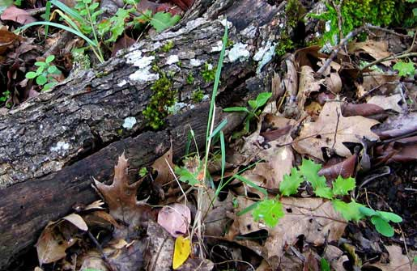
Teacher: __________________Grade:___ Period: _________ Date: ______ Initials: ____ ____ ____

Decomposers Pretest and Posttest
1. A tree falls and gradually decays while it is sitting on the ground. Answer these questions about what is happening to the materials and energy in the tree as it decays.

Do you think that materials (solids, liquids, or gases) are going into the decaying tree? (circle one answer below)  Yes No I’m not sure | Do you think that energy is going into the decaying tree? (circle one answer below)  Yes No I’m not sure
What materials do you think are going into the decaying tree? | What form(s) of energy do you think are going into the decaying tree?
Do you think that materials (solids, liquids, or gases) are coming out of the decaying tree? (circle one answer below)  Yes No I’m not sure | Do you think that energy is coming out of the decaying tree? (circle one answer below)  Yes No I’m not sure
What materials do you think are coming out of the decaying tree? | What form(s) of energy do you think are coming out of the decaying tree?
How do you think that materials are changing inside the decaying tree? | How do you think that energy is changing inside the decaying tree?
What are you not sure about in your answers? Explain what you need to know to answer these questions better.

2. A loaf of bread was left alone for 2 weeks. Three different kinds of mold grew on it. Assuming the bread did not dry out, which of the following is a reasonable prediction of the weight of the bread and mold after the 2-week period?
a. The mass increases, because the mold has grown.
b. The mass remains the same as the mold converts bread into biomass.
c. The mass decreases as the growing mold converts bread into energy.
d. The mass decreases as the mold converts bread into biomass and gases.

Explain your reasoning. How does decay affect the combined weight of the bread and the mold?

3. When a tree is alive it has energy stored in its living parts (roots, trunk, branches and green leaves). When the tree dies all the parts are still there (including fallen brown leaves). How much of the energy stored in the living tree is still there in the dead tree?
a. ALL of the energy
b. MOST of the energy
c. SOME of the energy
d. A LITTLE of the energy
e. NONE of the energy
What kinds of energy are stored in the dead tree (if any)? How are they connected to the energy in the living tree?

What happens to the energy stored in the tree when the dead tree decays?

4. A potato is left outside and gradually decays. One of the main materials in the potato is the starch, which is made of many sugar molecules (C₆H₁₂O₆) bonded together. What happens to the atoms in starch molecules as the potato decays? Circle True (T) or False (F) for each option.
T F Some of the atoms are changed into soil nutrients: nitrogen and phosphorus.
T F Some of the atoms are used up by decomposers and no longer exist.
T F Some of the atoms go into the air in carbon dioxide.
T F Some of the atoms are turned into energy by decomposers.
T F Some of the atoms go into the soil in water.
Explain the pattern in your answers. What happens to the atoms in the starch when the potato decays?

5. Answer these true-false questions:
True False Carbon is a kind of atom.
True False Carbon is a kind of molecule.
True False There is carbon in a mushroom.
True False There is carbon in the soil of a forest.
True False There is carbon in the air.

Decomposers Pretest and Posttest with Commentary

We do not recommend that you grade this pretest. Use the students’ responses instead as formative assessment, telling you where they are starting. Level 4 (correct) responses to the questions are in blue bold italics below. There are also comments connecting the questions to unit activities in blue italics.

1. A tree falls and gradually decays while it is sitting on the ground. Answer these questions about what is happening to the materials and energy in the tree as it decays.

Do you think that materials (solids, liquids, or gases) are going into the decaying tree? (circle one answer below)  Yes No I’m not sure | Do you think that energy is going into the decaying tree? (circle one answer below)  Yes No I’m not sure  Any of these answers could be justified. Light and heat energy are being absorbed by the tree from its surroundings, but they do not play a direct role in the decay process
What materials do you think are going into the decaying tree?  Oxygen is the key material that is essential for the decay process. Other materials such as water help create the conditions for decay, but do not participate directly in the process. | What form(s) of energy do you think are going into the decaying tree? Light and heat energy are being absorbed by the tree from its surroundings, but they do not play a direct role in the decay process.
Do you think that materials (solids, liquids, or gases) are coming out of the decaying tree? (circle one answer below)  Yes No I’m not sure | Do you think that energy is coming out of the decaying tree? (circle one answer below)  Yes No I’m not sure
What materials do you think are coming out of the decaying tree?  Carbon dioxide, water, and soil minerals  Level 2 and 3 students are likely not to be aware that the primary product of decay in terms of mass is carbon dioxide, a gas. | What form(s) of energy do you think are coming out of the decaying tree?  Heat energy or thermal energy. Level 2 students, in particular, will think of decay as something that happens after the tree has lost its energy, so they will not think of decay as a process that transforms energy.
How do you think that materials are changing inside the decaying tree?  The polymers (such as cellulose and proteins) that the tree is made of are being digested by decomposers, who use the resulting monomers for biosynthesis and cellular respiration. The primary long term change is through cellular respiration, in which combines tree materials with O₂ to produce CO₂ and water.  Level 2 and 3 students will have much vaguer terms to describe what is happening to tree materials, such as “breaking down” or “recycling.” | How do you think that energy is changing inside the decaying tree?  Chemical energy in tree materials is being transformed to energy for cell functioning and ultimately to heat energy.  Some Level 2 students may believe that no energy is involved in decay.  Other Level 2 students and some Level 3 students may believe that energy is recycled through soil nutrients. (This process recycles, matter, but not energy.)
What are you not sure about in your answers? Explain what you need to know to answer these questions better.
Students who successfully identify things that the don’t know have taken a big step toward successful learning. Note your students’ questions and think about how they can be answered as the unit proceeds.

2. A loaf of bread was left alone for 2 weeks. Three different kinds of mold grew on it. Assuming the bread did not dry out, which of the following is a reasonable prediction of the weight of the bread and mold after the 2-week period?
a. The mass has increased, because the mold has grown.
b. The mass remains the same as the mold converts bread into biomass.
c. The mass decreases as the growing mold converts bread into energy.
d. The mass decreases as the mold converts bread into biomass and gases.

Explain your reasoning. How does decay affect the combined weight of the bread and the mold?
Level 4 responses recognize that there are multiple processes occurring as the mold grows on bread, and that only some of the mass of the bread will be incorporated into the mold biomass. The rest will be lost to the air in the form of gaseous waste (CO₂ and water vapor) as a result of cellular respiration.
Most students will probably not answer d, or give the Level 4 explanation.
- Level 2 students may choose a or b. They may believe that the mold uses the bread to grow without actually absorbing the materials the bread is made of, which would account for an increase in mass. Or they may believe that food not contributing to biomass becomes waste (feces), and as that is accounted for in the second picture, the overall mass will remain the same.
- Level 3 students may choose B or C. They are attempting to conserve matter but may not know that some of the matter is lost to the air due to cellular respiration. They may, however, explain that some of the matter from food was converted to energy, and this would account for mass lost from the system.

3. When a tree is alive it has energy stored in its living parts (roots, trunk, branches and green leaves). When the tree dies all the parts are still there (including fallen brown leaves). How much of the energy stored in the living tree is still there in the dead tree?
a. ALL of the energy
b. MOST of the energy
c. SOME of the energy
d. A LITTLE of the energy
e. NONE of the energy
What kinds of energy are stored in the dead tree (if any)? How are they connected to the energy in the living tree?
Level 4 responses will recognize that chemical energy is stored in the (C-C and C-H) bonds of organic substances that make up the tree, and that this is true whether the tree is alive or dead.

Levels 2 and 3 may believe that some or all of the energy in the tree is associated with being alive, so it disappears when the tree dies.
What happens to the energy stored in the tree when the dead tree decays?
Level 4 responses will recognize that the chemical energy stored in the tree will be released when the matter in the tree is absorbed by decomposers and used for cellular respiration. They may indicate that the chemical energy is transformed into energy for cell functions and heat energy and lost to the environment.

Level 2 and 3 may indicate that energy is involved in decay, with Level 3 responses explaining that the tree is a source of energy (food) for decomposers, and Level 2 responses explaining that the decomposers use energy to break down the materials in the tree.

4. A potato is left outside and gradually decays. One of the main materials in the potato is the starch, which is made of many sugar molecules (C₆H₁₂O₆) bonded together. What happens to the atoms in starch molecules as the potato decays? Circle True (T) or False (F) for each option.
T F Some of the atoms are changed into soil nutrients: nitrogen and phosphorus.
T F Some of the atoms are used up by decomposers and no longer exist.
T F Some of the atoms go into the air in carbon dioxide.
T F Some of the atoms are turned into energy by decomposers.
T F Some of the atoms go into the air in water.
Students who understand the Rules to Follow in the Three Questions (see Lesson 2 Activity 1 below) will know that the three false statements MUST be false, even if they know nothing about specifically what happens when potatoes decay, because they violate the Rules to Follow in the Three Questions. Developing this sense of necessity about conservation of matter and energy is a primary goal of all Carbon TIME units. Level 2 and 3 students will not have this sense of necessity.

5. Answer these true-false questions:
True False Carbon is a kind of atom.
True False Carbon is a kind of molecule.
True False There is carbon in a mushroom.
True False There is carbon in the soil of a forest.
True False There is carbon in the air.
Level 2 and Level 3 students often are not clear about the distinction between atoms and molecules. The first two questions in this series check for that understanding. The remaining questions check whether students are aware that all organic molecules contain carbon, as well as carbon dioxide in the air.

Activity 2: Discussion of What Happens to Decaying Materials

Guiding Question: What happens to decaying materials?

Duration: 25 minutes

Learning Objectives:
Students will:
- Share and record the classes’ initial ideas about what happens to decaying materials

Activity Description:
As students participate in this unit, they will collect evidence and develop explanations about decomposers as they decay materials. The evidence they collect will help students explain where mass comes from or goes as materials decay, and how this happens. This activity begins by eliciting students’ prior knowledge about what happens to materials as they decay.

Background Information:
Most students cannot explain that food is the main contributor to the mass of a decomposer, or how food gets broken down and reassembled as the body of a decomposer. Most students also do not associate food or decaying materials with the carbon dioxide that they breathe out. They know that food or decaying materials is “burned up” to provide energy, but they do not distinguish the “breaking down” of digestion from the “breaking down” of cellular respiration. Many students often believe that food or decaying materials is converted to energy.

This lesson provides students with a chance to express these ideas so that they can question and correct them later, and it provides you with formative assessment information understanding where your students are starting.

Materials:
- Time Lapse Movies: This gallery from Cornell Plant Pathology contains time lapse movies of fungi, molds, bacteria, slime molds and insects of interest to plant pathologists: http://www.plantpath.cornell.edu/PhotoLab/timelapse.html. We recommend the strawberries or the bagel for this initial discussion, but you may want to return to the mushrooms later in the unit. See the preface for other video options.
- What happens to decaying materials? poster (24x36) (in DecomposersPosters.pptx) and Post-it notes per pair of students (Option 1), OR
- PowerPoint Slide 2 in Lesson 1,2 Decay.pptx (Option 2)

Directions:
- Class debrief from the pretest.
Ask students to share some questions they have after taking the pretest.

- Watch a time-lapse video of a bagel or strawberries decaying
Have your students observe what happens to a decaying bagel using videos from Cornell Plant Pathology: http://www.plantpath.cornell.edu/PhotoLab/timelapse.html.

- FORMATIVE ASSESSMENT: List student ideas about what happens to decaying materials
Pose the question: “What happens to decaying materials?” Use either Option 1 (posters and Post-it notes) or Option 2 (PowerPoint slides) to record student ideas.

Some students may not use principles of conservation of matter to identify decaying matter as the source of matter and energy for fungi and other decomposers (and instead only think of decay as a natural process that destroys or recycles materials). Students may think that the materials disappear as they decay, and not recognize that atoms are transferred from the decaying material to the decomposers [for the purpose of either growth or for chemical energy to function].

Optional Lesson: What Makes Up Our Food?

If your students have completed either the Animals or the Plants units, we recommend that you go straight to the Bread Mold Investigation in Lesson 2. If you are doing Decomposers immediately after Systems and Scale, however, we recommend that you do Lesson 2: What Makes up our Food from the Animals unit either before or after the Bread Mold Investigation in Lesson 2.

Food for people is also food for decomposers. Both decomposers’ food sources and the decomposers themselves are made of the same kinds of organic molecules: primarily carbohydrates, fats, and proteins. Students will need some basic knowledge about these molecules to complete the molecular modeling activities in Lesson 3.

Lesson 2: Bread Mold Investigation

Role of this Lesson in Unit Sequence
Activity 1: Predict and Explain (PE) in Inquiry Sequence
Activity 2: Observe and Revise Explanations (OE) in Inquiry Sequence

Duration: about 1 hour, 45 min
Activity 1: Initial explanations and predictions ~45 minutes
Activity 2: Observations and revised explanations ~60 minutes

Guiding Question: What happens when materials decay?

Lesson Description: Students make specific predictions about what they will observe and why. They discuss the Three Question as ways to explain chemical changes. Finally, they compare results when they use digital balances and bromothymol blue (BTB) to measure changes in matter.

Learning Objectives:
Students will
- Investigate changes in mass and CO₂ concentration for decomposers decaying materials.
- Construct arguments that use evidence about changes in mass of food and organisms and CO₂ concentration to defend claims about movements of atoms when materials decay.
- Measure mass changes and detect changes in CO₂ concentration.
- Find patterns in data collected by multiple groups about changes in mass and CO₂ concentration.

Background Information:
Students can make observations of decomposers decaying bread that will help them answer the Three Questions. In class observations are at a macroscopic level, limiting students to information about mass changes, carbon dioxide increasing or decreasing in the air around the organism, and only some forms of energy (light, motion and sometimes heat). The observations that students make of the system will relate to all three processes of digestion, biosynthesis and cellular respiration. After this lesson, students practice explaining processes of digestion and biosynthesis separately from cellular respiration.

Student inquiry practices include making measurements, making claims based on evidence, and coming to consensus on results by finding patterns in sets of data. There are many ways that students have difficulty in all of these areas, although the same set of skills are practiced in other Carbon TIME units (Systems & Scale, Plants & Animals).

Lesson Materials:
For Activity 1: Bread Mold Initial Predictions and Explanations
- Lesson1,2 Decay.pptx slides 5-
- The poster and Post-it notes used to share ideas in Lesson 1: What Happens to Materials When They Decay? poster (11 x 17) OR Lesson1,2 Decay.pptx slide 2 with ideas recorded
- Initial Predictions and Explanations worksheet per student

For Activity 2: Bread Mold Observations and Explanations
- Lesson1,2 Decay.pptx slides 9-14
- Materials for bread mold investigation:
One digital balance
A large air-tight Ziplock container
Bromothymol blue (BTB) solution to detect CO₂ in the air inside the container
One plastic Petri dish for BTB
4 covered Petri dishes with molding bread (1 per student)
- Bread Mold Investigation Set up Checklist and Data Table (from the pre-lesson) per student
- Bread Mold: Observations and Explanations worksheet per student
- Decomposers Class Results.xlsx Excel file. Use the “Bread Mold Lesson 2” tab
- Class Results for Bread Mold Investigation poster (11 x 17)

Advance Prep:
- Students start bread molding at least 7 days before this lesson begins (see Pre-lesson).
- Students record the mass of molding bread in closed Petri dishes at the beginning of the investigation and (optional) at other points during the investigation.

Activity 1: Bread Mold: Initial Predictions and Explanations

Guiding Question: How can we predict and measure changes in mass and CO₂ concentrations while bread molds?

Duration: 30 minutes

Learning Objectives:
Students will
- Measure mass changes in decaying bread and other materials.
- Detect changes in CO₂ concentration in chambers with decaying materials.
- Construct arguments that use evidence about changes in mass of decaying materials and CO₂ concentration to defend claims about movements of atoms and chemical changes during decay.

Activity Description:
Students make predictions for the bread mold investigation to measure mass changes in decaying materials. Students make predictions and explain those predictions in terms of their initial ideas about answers to the Movement Question and the Carbon Question. This activity allows students to make predictions about mass changes in decaying materials over time and to provide evidence for two areas of investigation: 1) biosynthesis and digestion and 2) cellular respiration. The investigation will support student explanations of biosynthesis and digestion with the observations of mass loss gain of decaying materials.

Background Information:
Students can make predictions about decaying materials that will help them answer the Three Questions. In class observations are at a macroscopic level, limiting students to information about mass changes, carbon dioxide increasing or decreasing in the air around the decaying materials, and only some forms of energy (light, motion and sometimes heat). The observations that students make of the system will relate to all three processes of digestion, biosynthesis and cellular respiration. After this lesson, students practice explaining processes of digestion and biosynthesis separately from cellular respiration.

Materials:
- Lesson1,2 Decay.pptx slides 5-7
- The poster and Post-it notes used to share ideas in Lesson 1: What Happens to Materials When They Decay? poster (11 x 17) OR Lesson1,2 Decay.pptx slide 2 with ideas recorded
- Initial Predictions and Explanations: Lesson 2 Activity 1 worksheet per student
- Three Questions handout

Directions:
- Re-introduce the investigation question.
When materials decay, what happens? Remind students of the ideas that they had in Lesson 1:
Option 1: Show them notes that you took about students’ ideas and questions on Slide 2 of the Lesson1,2Decay.pptx slides
Option 2: Show them Post-it notes from students’ initial explanations on the What happens to Materials When They Decay? poster (11 x 17)

- Students write initial Explanations and Predictions. Pass out Initial Predictions and Explanations: Lesson 2 Activity 1 worksheet per student. Tell students that they will use the tools for investigation—digital balances and BTB—to investigate bread molding. Have the students write their predictions and explanations on the worksheet. Use slide 5 as students fill out the worksheets. You may remind them of the facts about matter and energy in Lesson1,2Decay.pptx slide 6.

- FORMATIVE ASSESSMENT: Students share ideas about the Three Questions.
Use Slide 7 to prompt a discussion of students’ predictions and how they are related to the Rules to Follow and Evidence to Look For columns of the Three Questions poster and the Three Questions handout.
This discussion will show that some students are still at Level 2 with respect to both their ideas about energy and their understanding of the questions. For example:
  - Do they have a sense of necessity about the connections between mass changes and movement of atoms: Do they recognize that if the mealworms lose mass, then atoms MUST be moving out of the mealworms?
  - Do they account for energy separately from matter, or do they suggest that some of the matter in the potato or mealworm might be converted to energy.
You do not need to correct these problems now; they will be addressed in the investigation and modeling activities to come.

- (Optional: Plan the investigation. Slide 8 shows a picture of the materials students will have for the investigation and prompts students to plan their own procedures. You can either plan the procedures with them or have them follow the procedures in the Lesson 2 Activity 2: Bread Mold: Observations and Conclusions worksheet.)

The Three Questions: Explaining Matter and Energy in Combustion and Life
Scientific explanations of processes include answers to three questions:
Question | Rules to Follow | Evidence to Look For
The Movement Question: Where are atoms moving?  Where are atoms moving from?  Where are atoms going to? | Atoms last forever in combustion and living systems  All materials (solids, liquids, and gases) are made of atoms | When materials change mass, atoms are moving  When materials move, atoms are moving
The Carbon Question: What is happening to carbon atoms?  What molecules are carbon atoms in before the process?  How are the atoms rearranged into new molecules? | Carbon atoms are bound to other atoms in molecules  Atoms can be rearranged to make new molecules | The air has carbon atoms in CO₂  Organic materials are made of molecules with carbon atoms  - Foods  - Fuels  - Living and dead plants and animals
The Energy Question: What is happening to chemical energy?  What forms of energy are involved?  How is energy changing from one form to another? | Energy lasts forever in combustion and living systems  C-C and C-H bonds have more stored chemical energy than C-O and H-O bonds | We can observe indicators of different forms of energy  - Organic materials with chemical energy  - Light  - Heat energy  - Motion

Name _______________________________ Teacher _________________ Date __________

Bread Mold: Initial Predictions and Explanations Worksheet
Lesson 2, Activity 1
You will be doing an investigation of bread molding. Here are the tools that you will have:
One digital balance
A large air-tight Ziplock container
Bromothymol blue (BTB) solution to detect CO₂ in the air inside the container
One plastic Petri dish for BTB
A Petri dish of moldy bread that you have weighed before
Make predictions that will help you answer the Movement Question, the Carbon Question, and the Energy Question.
Predictions about mass changes: What are your predictions about objects or materials that will gain or lose mass?  What will gain mass?  What will lose mass? | Predictions about changes in BTB: Do you think that BTB will change color if it is in a sealed container with the decaying bread?  YES NO  What color change do you predict?
The Movement Question: Explaining your predictions about mass changes: Draw your ideas about how atoms are moving on the picture below.  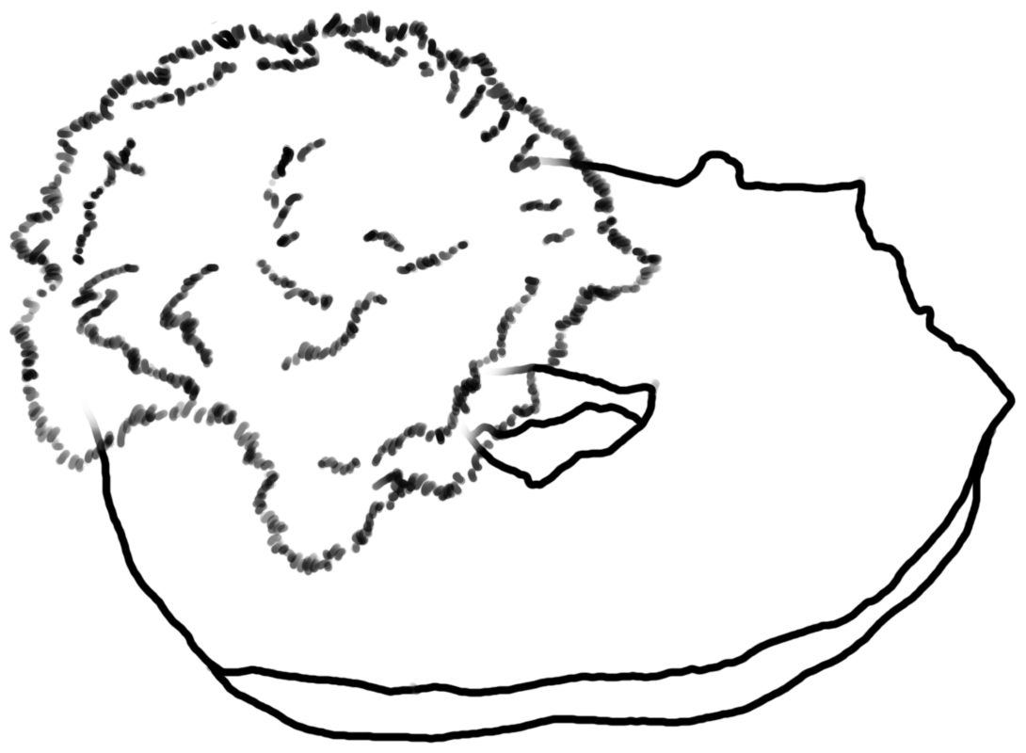 | The Carbon Question: Explaining your predictions about BTB color changes: What do you think is happening to molecules that have carbon atoms in them?
Where are atoms moving from?  Where are atoms going to? | The Energy Question: Explaining changes in forms of energy: How do you think that energy is changing from one form to another?

Assessing Bread Mold: Initial Predictions and Explanations Worksheet
Lesson 2, Activity 1
Students’ responses to the questions on this worksheet will be useful for formative assessment and for discussion of the results of their investigations. It would NOT be appropriate to grade their responses for correctness. Notes about what to notice about students’ responses are below.
You will be doing an investigation of bread molding. Here are the tools that you will have:
One digital balance
A large air-tight Ziplock container
Bromothymol blue (BTB) solution to detect CO₂ in the air inside the container
One plastic Petri dish for BTB
A Petri dish of moldy bread that you have weighed before
Make predictions that will help you answer the Movement Question, the Carbon Question, and the Energy Question.
Predictions about mass changes: What are your predictions about objects or materials that will gain or lose mass?  What will gain mass?  Do students have a sense of necessity about mass gain and loss? Do they recognize that if the moldy bread loses mass, then something else MUST gain mass?  What will lose mass?  Do students have a sense of necessity about the connections between their predictions about mass changes and the Movement Question below? Do they recognize that if the moldy bread loses mass, then atoms MUST be coming into it? | Predictions about changes in BTB: Do you think that BTB will change color if it is in a closed container with eating mealworms?  YES NO  What color change do you predict?  Most students will probably predict a color change from blue to yellow. Check to see how their predictions are connected to their ideas about the Carbon Question below. Are they asking where the carbon atoms in the CO₂ came from?
The Movement Question: Explaining your predictions about mass changes: Draw your ideas about how atoms are moving on the picture below. | The Carbon Question: Explaining your predictions about BTB color changes: What do you think is happening to molecules that have carbon atoms in them?
Where are atoms moving from?  Do student draw arrows showing going from the air into the moldy bread?  Where are atoms going to?  Do students draw arrows showing atoms moving into BOTH air and possibly recycled minerals or other waste?  Do students connect their arrows with their predictions about mass changes above? | The Energy Question: Explaining changes in forms of energy: How do you think that energy is changing from one form to another?  Some students will use matter-energy conversions as part of their responses or believe that energy is not involved in decay. That is OK for now.

Activity 2: Bread Mold Observations and Explanations

Guiding Question: What do we observe about changes in mass and CO₂ concentration when bread molds?

Duration: About 60 minutes

Learning Objectives:
Students will:
- Measure mass changes and detect changes in CO₂ concentration
- Find patterns in data collected by multiple groups about changes in mass and CO₂ concentration.
- Construct arguments that use evidence about changes in mass of molding bread and CO₂ concentration to defend claims about movements of atoms when bread molds.

Activity Description
Students work in groups of 4 to make and record observations of mass change in the decaying material, as well as BTB color change. They compare their observations with other groups in the class and with other classes, reaching conclusions about patterns in the observations, suggest explanations, and note unanswered questions.

Background Information:
Students can make observations of decaying materials that will help them answer the Three Questions. In class observations are at a macroscopic level, limiting students to information about mass changes, carbon dioxide increasing or decreasing in the air around the organism, and only some forms of energy (light, motion and sometimes heat). The observations that students make of the system will relate to all three processes of digestion, biosynthesis and cellular respiration. After this lesson, students practice explaining processes of digestion and biosynthesis separately from cellular respiration.

Student inquiry practices include making measurements, making claims based on evidence, and coming to consensus on results by finding patterns in sets of data. There are many ways that students have difficulty in all of these areas, although the same set of skills are practiced in other Carbon TIME units (Systems & Scale, Plants & Animals).

Materials:
- Lesson 1,2 Decay.pptx slides 10-16
- Materials for bread mold investigation: per group of 4 students
One digital balance
A large air-tight Ziplock container
Bromothymol blue (BTB) solution to detect CO₂ in the air inside the container
One plastic Petri dish for BTB
4 covered Petri dishes with molding bread (1 per student)
- Bread Mold Investigation Set up Checklist and Data Table (from the pre-lesson) per student
- Bread Mold: Observations and Explanations worksheet per student
- Decomposers Class Results.xlsx Excel file. Use the “Bread Mold Lesson 2” tab
- Class Results for Bread Mold Investigation poster (11 x 17)

Directions:

- Students collect data on bread mold investigation.
Students work in groups of 4. They either follow the procedures that they developed themselves or follow the procedure in Bread Mold: Observations and Explanations worksheet. Slide 10 has a picture of the setup for the investigation. Slide 11 reminds students of the range of BTB colors.
- Each student records the mass of his or her own Petri dish on the Bread Mold Investigation Set up Checklist and Data Table (from the pre-lesson)
- Each group adds up the total mass of the four Petri dishes, and students record the totals on the Bread Mold Investigation Set up Checklist and Data Table (from the pre-lesson)

- Collect and compare data from different groups.
Have each group record results on the Class Results for Bread Mold Investigation poster. Use the blank Decomposers Class Results.xlsx file to record and discuss results. Slide 12: Discuss patterns that students see in the class results. Use Slides 13 and 14 to compare results from your class with results from other classes. Do you see the same patterns?

3. FORMATIVE ASSESSMENT: Discuss students’ explanations of the results.
Students should recognize that while the mass changes provide them with good evidence to answer the Movement Question, the BTB evidence provides only a partial answer to the Carbon Question. It shows that carbon ENDS UP in CO₂ in the air, but not where the carbon came from in the mealworm. Students write answers Bread Mold: Observations and Explanations worksheet. Slide 15 prompts students to return to their earlier answers to the Movement Question and the Carbon Question. They should do two things:
- Consider whether the results suggest changes to their earlier answers to these questions.
- Identify UNANSWERED QUESTIONS that they still must answer before they can fully answer the Carbon Question, in particular. They probably still do not know the molecules in the mealworms that are the source of the carbon dioxide. They might observe energy in that the mealworms are moving, but may not be able to trace where the energy came from.

This discussion can be helpful for formative assessment in two ways:
- It can help you assess your students’ skills in identifying sources of error and finding patterns in data (see discussion under Lesson 2 above.
- It can help you assess how well students identify the limits of the evidence. Do they recognize that the investigation does not fully answer the Carbon Question or the Energy Question?

Name _______________________________ Teacher _________________ Date __________

Bread Mold: Observations and Explanations Worksheet
Lesson 2, Activity 2
Procedures to follow:
1. ☐ After 7 days, find the final mass of your Petri dish. DO NOT open the lid as classmates may have allergies to bread-mold. Turn on your digital scale until it reads 0.00g. Place the entire petri dish with the lid onto the scale. Record the final mass of your Petri dish and the total mass of your group’s Petri dishes on your investigation worksheet.
2. ☐ Stack all of your group’s Petri dishes in a large, sealable Ziplock container. Beside the stack of decomposers, place an open petri dish with BTB in it. Record the color of the BTB. Seal the Ziplock container.
3. ☐ After 24 hours, return to your sealed decomposer container. Open the container and immediately record the color of the BTB. You may wish to compare it to the color of fresh BTB in a petri dish, with both placed on a piece of white paper. After you’ve recorded the color of the BTB, you may discard your petri dishes containing decomposers.
B. Measurements during the investigation. Record your measurements on the table below.
Mass of your decomposer | Total mass of your group’s decomposers | Changes in color of BTB
Beginning mass: __________ grams  End mass: _______________ grams  Change in mass: __________ grams | Beginning mass: __________ grams  End mass: _______________ grams  Change in mass: __________ grams | Color before:  Color after:  _____________
C. Results for the whole class: Make notes about how the measurements and observations of other groups in the class compared to yours.
Changes in mass for the whole class | Changes in color of BTB for the whole class
D. Explaining your results: Try to write an explanation of your class results that includes answers to all Three Questions: the Movement Question, the Carbon Question, and the Energy Question

E. UNANSWERED QUESTIONS: What questions about movement of atoms, about molecules with carbon atoms, or about changes in forms of energy can you NOT answer based on evidence from the investigation? Write your ideas below.

Grading Bread Mold: Observations and Explanations Worksheet
Lesson 2, Activity 2
It is reasonable to grade students’ work on this worksheet.
Procedures to follow:
1. ☐ After 7 days, find the final mass of your Petri dish. DO NOT open the lid as classmates may have allergies to bread-mold. Turn on your digital scale until it reads 0.00g. Place the entire petri dish with the lid onto the scale. Record the final mass of your Petri dish and the total mass of your group’s Petri dishes on your investigation worksheet.
2. ☐ Stack all of your group’s Petri dishes in a large, sealable Ziplock container. Beside the stack of decomposers, place an open petri dish with BTB in it. Record the color of the BTB. Seal the Ziplock container.
3. ☐ After 24 hours, return to your sealed decomposer container. Open the container and immediately record the color of the BTB. You may wish to compare it to the color of fresh BTB in a petri dish, with both placed on a piece of white paper. After you’ve recorded the color of the BTB, you may discard your petri dishes containing decomposers.
B. Measurements during the investigation. Record your measurements on the table below.
Each student should be responsible for accurately recording his or her group’s measurements and observations.
Mass of your decomposer | Total mass of your group’s decomposers | Changes in color of BTB
Beginning mass: __________ grams  End mass: _______________ grams  Change in mass: __________ grams | Beginning mass: __________ grams  End mass: _______________ grams  Change in mass: __________ grams | Color before:  Color after:  _____________
C. Results for the whole class: Make notes about how the measurements and observations of other groups in the class compared to yours.
Changes in mass for the whole class  Most of the decomposers lost mass. | Changes in color of BTB for the whole class  Most of the BTB samples changed from blue or green to yellow.
D. Explaining your results: Try to write an explanation of your class results that includes answers to all Three Questions: the Movement Question, the Carbon Question, and the Energy Question
Movement Question: Atoms left the molding bread and went into the air.
Carbon Question: Carbon atoms went into CO₂ molecules.
Energy Question: No clear evidence about what is happening to energy (but it could be that high-energy bonds in the bread are being replaced by low-energy bonds in CO₂.)
E. UNANSWERED QUESTIONS: What questions about movement of atoms, about molecules with carbon atoms, or about changes in forms of energy can you NOT answer based on evidence from the investigation? Write your ideas below.
This investigation does not provide complete answers to the Carbon Question (what molecules in the bread are the carbon atoms in CO2 coming from?) or the Energy Question (what is happening to the high energy bonds in the organic molecules of the bread?).

Lesson 3: Explaining How Decomposers Grow and Function

Role of this Lesson in the Unit Sequence:
Activity 1: Modeling and coaching in application sequence for digestion and biosynthesis
Activity 2: Modeling and coaching in application sequence for cellular respiration
Optional Activity: Modeling and coaching in application sequence for cellular respiration

Duration: about 2 hours (not including optional activity)
Activity 1: Explaining What Happens When Mushrooms Grow ~ 25 minutes
Activity 2: Modeling Digestion and Biosynthesis in Fungi ~ 50 minutes
Activity 3: Cellular Respiration in Fungi ~ 40 minutes
Optional Activity: Modeling Cellular Respiration ~ 50 minutes

Guiding Question: How do mushrooms grow and function?

Learning Objectives:
Students will:
- Describe systems and processes in fungi in a hierarchy of scales, including atomic-molecular and macroscopic scales.
- Draw and explain movements of materials during decay processes.
- Identify the most abundant organic materials in decaying matter—fats, proteins, and carbohydrates—and use food labels to find out how concentrated they are in different foods and animal tissues.
- Explain the chemical changes that occur during decay, including materials being incorporated into biomass of decomposers and cellular respiration, representing the changes with molecular models and chemical equations.
- Identify forms of energy involved in decay: chemical energy, movement, and heat energy.
- Explain energy transformations during decay processes. In particular, chemical energy stored in C-C and C-H bonds of organic molecules is used to support life processes in decomposers and ultimately converted to heat.

Background Information:
In lesson 2, students measured mass changes and detected changes in CO₂ concentrations in decaying materials. However, students do not have all the answers to the Carbon Question (what molecules in the bread are the carbon atoms in CO2 coming from?) or the Energy Question (what is happening to the high energy bonds in the organic molecules of the bread?).

Students will learn that carbohydrates, proteins, and fats are materials that decomposers ingest to give them mass to grow. If students completed the Animals unit, they know these materials are carbon-based and that they have chemical energy. Most of your students will know that when these substances are ingested by decomposers, Students likely cannot trace these substances beyond the decomposer’s body. When these substances (which are polymers) are ingested, they are broken down into monomers in the digestive system. Once they are fully digested into monomers they can be transported across membranes into the bloodstream and then carried to all the cells in the body. At the cell they are transported into the cell body, and rebuilt through various biosynthetic processes back into polymers. The monomers that are the product of digestion can follow different pathways in the body and go through many different processes, but your students need to know a general storyline about what happens in growth: polymers are broken down into monomers through digestion, then rebuilt into polymers that become part of the decomposer’s biomass.

Growing is the macroscopic manifestation of two carbon-transforming processes: digestion and biosynthesis. Since Fungi break down polymers outside their bodies, the Movement Question for digestion can be answered as atoms are moving from food to the decomposer’s hyphae cells and through the mycelium. The cells in the hyphae send out digestive enzymes that break the polymer into monomers (small organic molecules). The small monomers then can enter the cells of the hyphae and travel through the mycelium.The Movement Question for biosynthesis can be answered as atoms are moving from the hyphae to the mycelium. The Carbon Question for digestion can be answered as organic carbon in polymers are rearranged into monomers. The Carbon Question for biosynthesis can be answered as organic carbon in monomers is again rearranged into polymers. The Energy Question for both digestion and biosynthesis is that all of food polymers, monomers and biomass polymers have chemical energy.

Fungi obtain the energy they need to function through the rearrangement of atoms during metabolic processes. This is the sole purpose of cellular respiration in all living organisms. Every living organism, from the smallest bacteria to the largest tree in the forest, needs to acquire a source of chemical energy, which is found in organic matter. Once organic matter is oxidized, the chemical energy found in the high-energy bonds is transformed into chemical energy in other high energy bonds (in ATP), then ultimately into kinetic energy and heat. The atoms once tied up in organic molecules are rearranged into inorganic water and carbon dioxide. Unfortunately, many students incorrectly see cellular respiration as the way we convert food or stored biomass (fat) into energy to move and exercise. Students even make these matter-energy conversions at the atomic-molecular scale when they learn about ATP (another organic molecule). Students need to develop an explanation of cellular respiration that conserves both matter and energy, and makes the connection between atomic-molecular transformations and macroscopic observations.

Using energy to move is the macroscopic manifestation of the carbon-transforming processes of cellular respiration. The Movement Question for cellular respiration can be answered as atoms are moving from the animal to the air. The Carbon Question for cellular respiration can be answered as organic carbon in food or biomass is rearranged into carbon dioxide. The Energy Question for cellular respiration can be answered as food or biomass has chemical energy, but carbon dioxide does not.

Lesson Description:

Within lesson 3, students will begin to describe systems using the atomic-molecular and macroscopic scales. Using food labels, students learn that the biomass of living things is actually carbohydrates, fats, and proteins similar to those things found in food. In activity 1, students compare Fungi to Plants and Animals. Students will have a difficult time explaining how fungi digest their food without a digestive system, but within this lesson they will better understand the process. Students will then complete a paperclip activity that focuses on details in the processes of digestion and biosynthesis and the location of all of those processes in a mushroom. Within this lesson, students model cellular respiration to see that organic materials with chemical energy are changed into inorganic water and carbon dioxide. The lesson concludes with a final explanation of movement and cellular respiration using the Three Questions.

Lesson Materials:

For Activity 1: Explaining What Happens When Mushrooms Grow
- Optional videos and multimedia
  - National Geographic Podcast from Encyclopedia of Life: http://education.nationalgeographic.com/education/multimedia/fungi/?ar_a=1
  - Time-lapse videos from Cornell Plant Pathology contains time lapse movies of fungi, molds, bacteria, slime molds and insects of interest to plant pathologists: http://www.plantpath.cornell.edu/PhotoLab/timelapse.html. We recommend the strawberries or the bagel for this initial discussion, but you may want to return to the mushrooms later in the unit.
    - http://www.youtube.com/watch?v=Yv0p_JNYSgc
    - http://www.youtube.com/watch?v=msFWsPWfd6Q
  - YouTube videos might be useful for showing different decomposers:
    - http://www.youtube.com/watch?v=4csB8VRz-cQ&NR=1
  - Fungi Growth Videos:
    - http://www.youtube.com/watch?v=SGQBgPbzums&feature=fvsr
    - http://www.youtube.com/watch?v=0VXdco-WzNA&feature=relmfu
  - Bacteria Growth Videos:
    - http://www.youtube.com/watch?v=y3TOZ_abECM
    - http://www.youtube.com/watch?v=eqrtNef7w38
  - General Decomposition video (turn narrator off or on):
    - http://www.youtube.com/watch?v=5kG18FYISaY
- Lesson 3 Explaining Fungi.pptx slides 1 - 9
- Explaining What Happens When Mushrooms Grow Worksheet per student

For Activity 2: Modeling Digestion and Biosynthesis in Fungi
- Lesson 3 Explaining Fungi.pptx slides 10-26
- Modeling Digestion and Biosynthesis Worksheet per student
- Mushroom Poster (11 x 17), per pair of students
- Paper clips, 20 per pair of students
- Monomer Cards, cut into pieces, one sheet per pair of students
- Polymer Cards, cut into pieces, one sheet per pair of students (optional, recommended for middle school)

For Activity 3: Cellular Respiration in Fungi
- Lesson 3 Explaining Fungi.pptx slides 27-33
- Explaining Cellular Respiration in Fungi worksheet per student

For Optional Activity: Modeling Cellular Respiration
- See materials list for Lesson 5, Activity 2 in the Animals unit: Using Molecular Models to Explain Cellular Respiration

Activity 1: Explaining What Happens When Mushrooms Grow

Duration: about 25 minutes

Guiding Question: How do mushrooms grow?

Learning Objectives:
Students will:
- Describe systems and processes in fungi in a hierarchy of scales, including atomic-molecular and macroscopic scales.
- Identify the most abundant organic materials in decaying matter, including proteins and carbohydrates, and use food labels to find out how concentrated they are in different foods and animal tissues.

Activity Description:
Using the results from the bread mold investigation students will understand how fungi compare to plants and animals. This comparison will be made using the data about mass changes and CO₂ concentration. Students will work with the movement and carbon questions by looking at a food label and determining what organic materials would be in fungus.

Background Information:
Growing is the macroscopic manifestation of two carbon-transforming processes: digestion and biosynthesis. Since Fungi break down polymers outside their bodies, the Movement Question for digestion can be answered as atoms are moving from food to the decomposer’s hyphae cells and through the mycelium. The cells in the hyphae send out digestive enzymes that break the polymer into monomers (small organic molecules). The small monomers then can enter the cells of the hyphae and travel through the mycelium. The Movement Question for biosynthesis can be answered as atoms are moving from the hyphae to the mycelium. The Carbon Question for digestion can be answered as organic carbon in polymers are rearranged into monomers. The Carbon Question for biosynthesis can be answered as organic carbon in monomers is again rearranged into polymers. The Energy Question for both digestion and biosynthesis is that all of food polymers, monomers and biomass polymers have chemical energy.

Materials:
- Optional videos and multimedia
  - Time-lapse videos from Cornell Plant Pathology contains time lapse movies of fungi, molds, bacteria, slime molds and insects of interest to plant pathologists: http://www.plantpath.cornell.edu/PhotoLab/timelapse.html. We recommend the strawberries or the bagel for this initial discussion, but you may want to return to the mushrooms later in the unit.
    - http://www.youtube.com/watch?v=Yv0p_JNYSgc
    - http://www.youtube.com/watch?v=msFWsPWfd6Q
  - YouTube videos might be useful for showing different decomposers:
    - http://www.youtube.com/watch?v=4csB8VRz-cQ&NR=1
  - Fungi Growth Videos:
    - http://www.youtube.com/watch?v=SGQBgPbzums&feature=fvsr
    - http://www.youtube.com/watch?v=0VXdco-WzNA&feature=relmfu
  - Bacteria Growth Videos:
    - http://www.youtube.com/watch?v=y3TOZ_abECM
    - http://www.youtube.com/watch?v=eqrtNef7w38
  - General Decomposition video (turn narrator off or on):
    - http://www.youtube.com/watch?v=5kG18FYISaY
- Lesson 3 Explaining Fungi.pptx slides 1 - 9
- Explaining What Happens When Mushrooms Grow Worksheet per student

Directions:

1. Discuss whether decomposers are more like plants or more like animals
a. Hand out the Explaining What Happens When Mushrooms Grow Worksheet to each student and ask students to complete Part A: Comparing Plants, Animals, and Fungi
b. Use Slide 4 to lead a discussion in which students share their ideas. They should conclude that decomposers are more like animals than plants.

2. Ask students for their ideas about how mushrooms can digest food without digestive systems.
Optional: Show students the time-lapse videos of mushroom growth or the National Geographic podcast. Ask them to notice the structure of the fungi, and to think about where digestion might be happening.
Show Slides 5-6, showing the structure of a mushroom and asking the question: How can mushrooms digest food without digestive systems?

3. Compare the materials in mushrooms with the materials in dead plants
a. Show Slide 7 and ask students to look at the mushroom food label and complete questions 1 and 2 in Part B: Answering the Movement Question and the Carbon Question in the Explaining What Happens When Mushrooms Grow Worksheet.
b. Use Slides 8 and 9 to point out that mushrooms are made of materials that are similar to plants, but not exactly the same.
c. Use the question on Slide 9--How can mushrooms make their polymers from plant polymers?—as a transition to the paperclip modeling activity.

Name _______________________________ Teacher _________________ Date __________

Explaining What Happens When Fungi Grow
Lesson 3, Activity 1
A. Comparing plants, animals, and fungi. Are fungi more like animals or more like plants? They look more like plants, but what can we learn from the results of our investigations?
1. Complete the table below.
Kind of Organism | Changes in Mass | Changes in CO₂
Plants growing in the light | Plants gain more mass than the soil loses, so plants and soil combined gain mass | Plants in the light absorb CO₂ from the air
Growing animals (e.g., mealworms, cows, people) | Animals gain less mass than their food loses, so animals and food combined lose mass | Animals add CO₂ to the air when they breathe
Bread mold (your investigation)

2. In terms of how they eat and breathe, are fungi more like plants or more like animals?
Choose one: More like plants More like animals
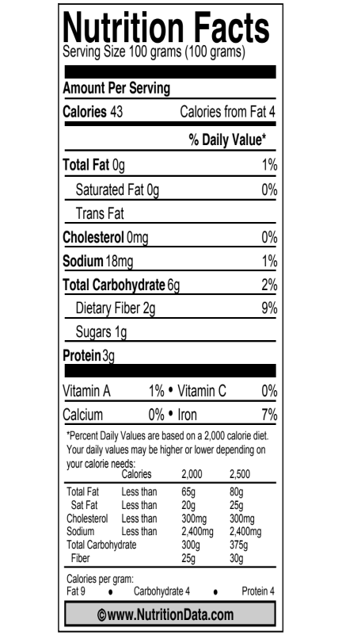
B. Answering the Movement Question and the Carbon Question: How can fungi digest their food and grow if they don’t have digestive systems? Like animals, fungi have to digest their food, but how can they do that if they don’t have mouths, stomachs, or intestines? A mushroom is the fruiting body of a fungus (sort of like the apple on an apple tree). It spreads spores from the fungus to other places where fungi can grow. The main body of the mushroom is called the mycelium; it is an underground network of thin fibers called hyphae.
1. The Nutrition Facts label shows some of the materials that are in mushrooms. Look at the label and list some of the important materials in mushrooms:
Materials in mushrooms:
1.

2.

3.

2. The fungus depends on dead plants and animals as a food source. List some of the materials that you would expect to find in dead plants and animals. (Hint: Can you find other nutrition labels that show the materials in dead plants and animals?) Materials in dead plants and animals:
1.

2.

3.

Grading Explaining What Happens When Fungi Grow Worksheet
Lesson 3, Activity 1
It is reasonable to grade this worksheet as summative evaluation. Correct answers are in bold blue italics; other comments are in regular blue italics
A. Comparing plants, animals, and fungi. Are fungi more like animals or more like plants? They look more like plants, but what can we learn from the results of our investigations?
1. Complete the table below.
Kind of Organism | Changes in Mass | Changes in CO₂
Plants growing in the light | Plants gain more mass than the soil loses, so plants and soil combined gain mass | Plants in the light absorb CO₂ from the air
Growing animals (e.g., mealworms, cows, people) | Animals gain less mass than their food loses, so animals and food combined lose mass | Animals add CO₂ to the air when they breathe
Bread mold (your investigation) | Fungi (or bread mold) and food (or bread) combined lose mass | Fungi add CO₂ to the air
2. In terms of how they eat and breathe, are fungi more like plants or more like animals?
Choose one: More like plants More like animals
B. Answering the Movement Question and the Carbon Question: How can fungi digest their food and grow if they don’t have digestive systems? Like animals, fungi have to digest their food, but how can they do that if they don’t have mouths, stomachs, or intestines? A mushroom is the fruiting body of a fungus (sort of like the apple on an apple tree). It spreads spores from the fungus to other places where fungi can grow. The main body of the mushroom is called the mycelium; it is an underground network of thin fibers called hyphae.
The Nutrition Facts label shows some of the materials that are in mushrooms. Look at the label and list some of the important materials in mushrooms:
Materials in mushrooms:
1. Carbohydrates (starch, sugars, or fiber/cellulose would all be acceptable answers. The fiber in mushrooms is actually chitin, a molecule similar to cellulose.)
2. Protein
3. Other acceptable answers include water (actually over 90% of the mass of a mushroom), fat, minerals such as sodium, and vitamins.
The fungus depends on dead plants and animals as a food source. List some of the materials that you would expect to find in dead plants and animals. (Hint: Can you find other nutrition labels that show the materials in dead plants and animals?) Materials in dead plants and animals:
1. Carbohydrates (starch, sugars, or fiber/cellulose would all be acceptable answers)
2. Protein
3. Other acceptable answers include water fat, minerals such as sodium , and vitamins.

Activity 2: Modeling Digestion and Biosynthesis in Fungi

Duration: about 50 minutes

Guiding Question: How do mushrooms grow?

Learning Objectives:
Students will:
- Describe systems and processes in fungi in a hierarchy of scales, including atomic-molecular and macroscopic scales.
- Draw and explain movements of materials during decay processes.
- Explain the chemical changes that occur during decay, including materials being incorporated into biomass of fungi.

Activity Description:
In this activity students will use paperclips to model the breakdown (digestion) and rebuilding (biosynthesis) of key polymers ingested when materials decay. The story focuses on the general breakdown of polymers into monomers and rebuilding back to polymers inside the cells. During the activity, students place monomers and polymers on a poster of a mushroom to represent where these processes are occurring in the mushroom.

Background Information:
Growing is the macroscopic manifestation of two carbon-transforming processes: digestion and biosynthesis. Since Fungi break down polymers outside their bodies, the Movement Question for digestion can be answered as atoms are moving from food to the decomposer’s hyphae cells and through the mycelium. The cells in the hyphae send out digestive enzymes that break the polymer into monomers (small organic molecules). The small monomers then can enter the cells of the hyphae and travel through the mycelium. The Movement Question for biosynthesis can be answered as atoms are moving from the hyphae to the mycelium. The Carbon Question for digestion can be answered as organic carbon in polymers are rearranged into monomers. The Carbon Question for biosynthesis can be answered as organic carbon in monomers is again rearranged into polymers. The Energy Question for both digestion and biosynthesis is that all of food polymers, monomers and biomass polymers have chemical energy.

Tips and Modifications:
The activity is written to have students trace food polymers in dead plant material to the hyphae of the mushroom. Another option is to have students build starch, cellulose, and protein polymer models at the same time, but to keep these molecules to the side of the poster. These molecules could also be transformed at each step without moving them on the poster as the poster quickly gets crowded with paperclip models.

Middle school modification: use the monomer cards and polymer cards (without paperclips) to trace food molecules during digestion and biosynthesis. Students will not be expected to use the names of different polymers and monomers in their explanations of digestion and biosynthesis, so the emphasis can be on “large molecules” and “small molecules” and noticing what atoms make up those molecules. When polymers are rearranged into monomers (and vice-versa) students can simply trade large and small molecule cards rather than paper-clipping specific monomers together.

Materials:
- Lesson 3 Explaining Fungi.pptx slides 10-26
- Modeling Digestion and Biosynthesis Worksheet per student
- Mushroom Poster (11 x 17), per pair of students
- Paper clips, 20 per pair of students
- Monomer Cards, cut into pieces, one sheet per pair of students
- Polymer Cards, cut into pieces, one sheet per pair of students (optional, recommended for middle school)

Directions:

1. Discuss external digestion in fungi
a. Use Slide 11 to pose the question: How can a fungus digest food without a digestive system? Discuss students’ ideas about how this might happen.
b. Use Slides 12 and 13 to present the answer to this question: Fungi digest food outside their bodies by secreting digestive enzymes that break polymers down into monomers that can be absorbed by cells in the hyphae.

2. Introduce the paperclip modeling activity
a. Pass out the materials listed on Slide 14: paperclips, monomer cards, and the Mushroom Poster for each pair of students, as well as the Modeling Digestion and Biosynthesis Worksheet for each student.
b. Ask students to locate to food for the fungus (dead plant material) on the poster.

3. Build Food Molecules
a. Use Slide 15 to guide students as they build molecules in food for a fungus, dead plant materials. Each pair of students should make at least one protein and one cellulose molecule.
b. Have students place the molecules in their location in the circle on the mushroom poster pointing to dead plant materials outside the fungus mycelium (network of hyphae).

4. Digest Food Molecules
a. Use Slides 16, 17, and 18 to guide students through modeling digestion—breaking the cellulose and protein polymers into glucose and amino acid monomers. NOTE: The video clip on Slide 18 will work ONLY if the video file digestion atom.avi is in the same folder as the Lesson 3 Explaining Fungi.pptx file. You can also show the video file separately.
b. Use Slide 19 to discuss how the monomers can move into the cells of the hyphae of the fungus.
c. Have students complete the digestion process tool on the Modeling Digestion and Biosynthesis Worksheet.
d. Use Slide 20 to discuss students’ answers to the Three Questions. Check to make sure that they are considering the Rules to Follow at the bottom of the slide.

5. Students move monomers through the mycelium to the mushroom.
Use Slides 21 and 22 to guide students as they move their monomers through the mycelium to the fruiting body—the mushroom

6. Students build mushroom polymers
a. Use Slides 23, 24, and 25 to guide students through modeling biosynthesis—connecting the glucose and amino acid monomers to make starch and protein polymers. NOTE: The video clip on Slide 25 will work ONLY if the video file Protein synthesis.avi is in the same folder as the Lesson 3 Explaining Fungi.pptx file. You can also show the video file separately.
b. Have students complete the digestion process tool on the Modeling Digestion and Biosynthesis Worksheet.
c. Use Slide 26 to discuss students’ answers to the Three Questions. Check to make sure that they are considering the Rules to Follow at the bottom of the slide.

Monomer Cards (Small Organic Molecules) 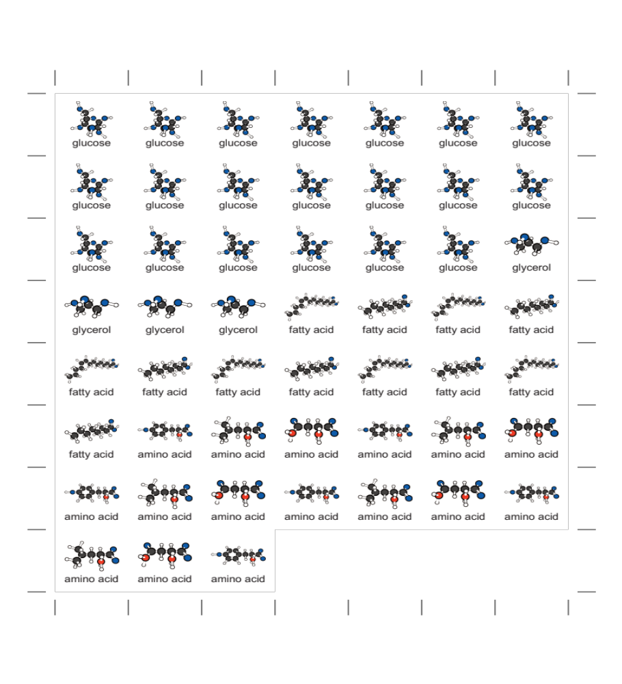

Polymer Cards (Large Organic Molecules)

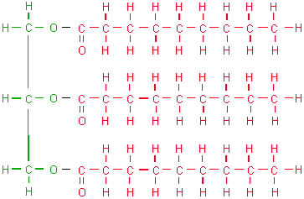 | 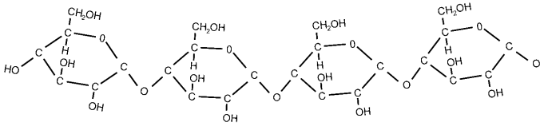
Fats | Starches
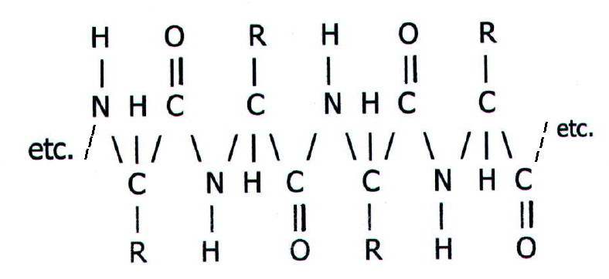 | 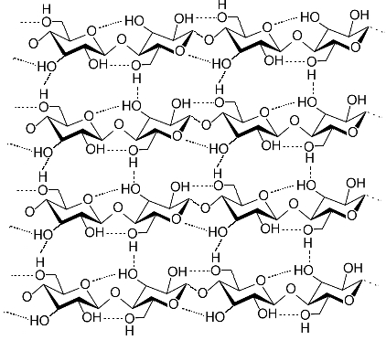
Proteins | Cellulose (dietary fiber)

Name _______________________________ Teacher _________________ Date __________

Modeling Digestion and Biosynthesis
Lesson 3, Activity 2
Use the Process Tool below to answer the Three Questions using for fungi DIGESTING food.
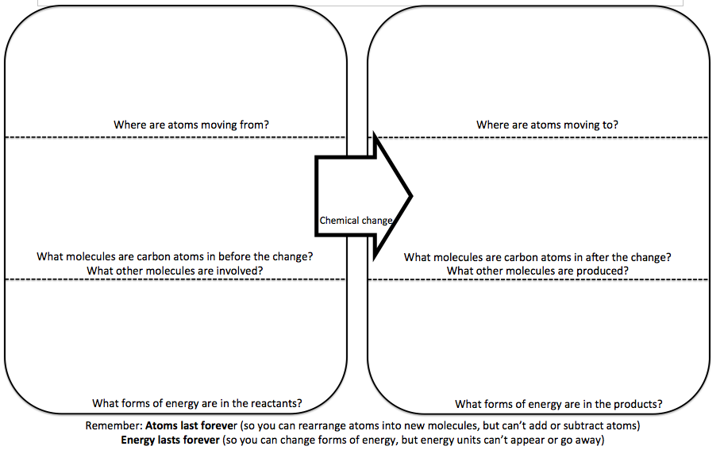
Use the Process Tool below to answer the Three Questions for fungi BIOSYNTHESIZING mushrooms.

Grading Modeling Digestion and Biosynthesis
It is reasonable to grade students’ responses to this worksheet as summative evaluation.
Use the Process Tool below to answer the Three Questions using for fungi DIGESTING food.
Atoms are moving from the food
Atoms are moving to the animal’s digestive and then circulatory systems
Carbon atoms are in polymers (big molecules)
Carbon atoms are in monomers (small molecules)
Chemical energy associated with polymers (big molecules)
Chemical energy associated with monomers (small molecules)

Use the Process Tool below to answer the Three Questions for fungi BIOSYNTHESIZING mushrooms.
Atoms are moving from the circulatory system
Atoms are moving to the muscle cells
Carbon atoms are in monomers (small molecules)
Carbon atoms are in polymers (big molecules)
Chemical energy associated with monomers (small molecules)
Chemical energy associated with polymers (big molecules)

Activity 3: Cellular Respiration in Fungi

Guiding Question: How do cells in fungi get their energy?

Duration: 40 minutes

Learning Objectives:
Students will:
- Draw and explain movements of materials during decay processes.
- Explain the chemical changes that occur during decay, including cellular respiration, representing the changes with verbal descriptions and chemical equations.
- Identify forms of energy involved in decay: chemical energy, movement, and heat energy.
- Explain energy transformations during decay processes. In particular, chemical energy stored in C-C and C-H bonds of organic molecules is used to support life processes in decomposers and ultimately converted to heat.

Activity Description:
Students use a mushroom model to draw and explain the movement of materials during decay. Students explain the chemical changes that occur during decomposition by verbally describing the process and writing a balanced equation. Using the Three Questions, students explain energy transformations during the decay process.

Background Information:
Fungi obtain the energy they need to function through the rearrangement of atoms during metabolic processes. This is the sole purpose of cellular respiration in all living organisms. Every living organism, from the smallest bacteria to the largest tree in the forest, needs to acquire a source of chemical energy, which is found in organic matter. Once organic matter is oxidized, the chemical energy found in the high-energy bonds is transformed into chemical energy in other high energy bonds (in ATP), then ultimately into kinetic energy and heat. The atoms once tied up in organic molecules are rearranged into inorganic water and carbon dioxide. Unfortunately, many students incorrectly see cellular respiration as the way to convert food or stored biomass into energy to move. Students even make these matter-energy conversions at the atomic-molecular scale when they learn about ATP (another organic molecule). Students need to develop an explanation of cellular respiration that conserves both matter and energy, and makes the connection between atomic-molecular transformations and macroscopic observations.

Materials:
For Activity 3: Cellular Respiration in Fungi
- Lesson 3 Explaining Fungi.pptx slides 27-33
- Explaining Cellular Respiration in Fungi worksheet per student

Directions:

1. Discuss students’ ideas about energy sources and matter movements for fungi
a. Ask students for their ideas about how cells in a fungus get the energy they need to grow and function (e.g., make digestive enzymes, absorb monomers, make polymers from monomers)
b. Have students complete Part A of the Explaining Cellular Respiration in Fungi worksheet. Ask them to share their ideas about how atoms are moving into and out of the fungus as it uses energy.
c. Use Slides 28 and 29 to discuss molecules that fungi can use as sources of chemical energy, and how food molecules (from the soil) and O₂ molecules (from the air) can reach cells in the fungus.

2. Students answer the Three Questions for cellular respiration in fungi.
a. Use Slide 30 to illustrate cellular respiration—the oxidation of glucose, making energy available when high-energy C-C and C-H bonds are replaced with lower-energy C-O and H-O bonds. NOTE: The video clip on Slide 30 will work ONLY if the video file Cell Respiration.avi is in the same folder as the Lesson 3 Explaining Fungi.pptx file. You can also show the video file separately.
b. Have students complete Part B of the Explaining Cellular Respiration in Fungi worksheet.
c. Use Slide 31 to prompt them to share their ideas about the Three Questions for cellular respiration in fungi.

3. Students write a balanced chemical equation for cellular respiration in fungi
a. Use Slide 32 to remind students of the rules for writing balanced chemical equations, then ask them to write the equation for cellular respiration: Part C of the Explaining Cellular Respiration in Fungi worksheet.

Name _______________________________ Teacher _________________ Date __________

Explaining Cellular Respiration in Fungi
Lesson 3, Activity 3
A. Answering the Movement Question for fungus cells using food for energy.
The Movement Question: Explaining the missing mass. The bread in the bread mold investigation lost mass when fungus grew on it. Where did the missing atoms go? | The Movement Question: Drawing motions of atoms: Draw arrows to show how atoms move into, through, and out of a fungus when its cells are using food as an energy source.  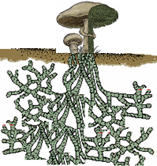
B. Answering the Three Questions. Use the Process Tool below to answer the Three Questions for fungi USING FOOD FOR ENERGY.
C. Writing the chemical equation. Use the molecular formulas (C₆H₁₂O₆, O₂, CO₂, H₂O) and the yield sign (→) to write a balanced chemical equation for CELLULAR RESPIRATION.

Grading Explaining Cellular Respiration in Fungi
This worksheet can be graded for summative evaluation. Correct answers are suggested below.
A. Answering the Movement Question for fungus cells using food for energy.
The Movement Question: Explaining the missing mass. The bread in the bread mold investigation lost mass when fungus grew on it. Where did the missing atoms go?  The missing mass went into gases in the air, including CO₂. NOTE that students have evidence for this from the BTB color change in the bread mold investigation. | The Movement Question: Drawing motions of atoms: Draw arrows to show how atoms move into, through, and out of a fungus when its cells are using food as an energy source.  Arrows should show food traveling through the hyphae to the mushroom. O₂ diffuses into the hyphae and mushroom from the air and CO₂ diffuses out, but students do not have a way to know this.)
B. Answering the Three Questions. Use the Process Tool below to answer the Three Questions for fungi USING FOOD FOR ENERGY.
Food or dead plant materials, air (O₂)
Air
Glucose, oxygen
Carbon dioxide, water
Chemical energy associated with glucose
Energy for cell functions and heat energy

C. Writing the chemical equation. Use the molecular formulas (C₆H₁₂O₆, O₂, CO₂, H₂O) and the yield sign (→) to write a balanced chemical equation for CELLULAR RESPIRATION.
C₆H₁₂O₆ + 6O₂ à 6 CO₂ + 6 H₂O

Optional activity: Using Molecular Models to Explain Cellular Respiration

Driving Question: How are atoms rearranged into new molecules during cellular respiration?

Learning Objectives:
Students will:
- Draw and explain movements of materials during decay processes.
- Explain the chemical changes that occur during decay, including cellular respiration, representing the changes with verbal descriptions and chemical equations.
- Identify forms of energy involved in decay: chemical energy, movement, and heat energy.
- Explain energy transformations during decay processes. In particular, chemical energy stored in C-C and C-H bonds of organic molecules is used to support life processes in decomposers and ultimately converted to heat.

Activity Description: Students explain the patterns of results in terms of a chemical change: the reaction of food or biomass and oxygen to produce carbon dioxide and water. They practice describing the chemical change in three different ways: using molecular models, a chemical equation, and the Process Tool.

Background Information, Materials, and Directions for Activities:
See Lesson 5, Activity 2 in the Animals unit.

Optional Reading: What is Cellular Respiration?

Duration: 20 minutes

Rationale & Description:
Students need to learn that cellular respiration transforms matter and energy, which is observable at the macro scale when we breathe, move, and radiate heat. In this activity students read about cellular respiration. As students complete the reading, you might consider constructing a diagram for them to see two pathways food might take after digestion. An example diagram might look like:

Biosynthesis: Monomers rebuilt into polymers and adds biomass.

Digestion: Breaks down polymers into monomers to get to cells
Ingested Food
Cell Respiration: Monomers react with oxygen to release chemical energy and give off CO₂ and H₂O

Pass out the reading What Is Cellular Respiration? As a class, read through this handout together, stopping at the various points described below for discussion.
  - First sentence: This sentence asks if eating and breathing are connected. Elicit 2-3 students’ ideas about this question.
  - Section: What we get from food: This section ends with a question about what students think happens when food is reacted with oxygen. Ask students to share their ideas to see if they can apply what they learned in Systems and Scale or other units to explain this process and possible outcomes.
  - Diagram: Examine the diagrams together, pointing out what is happening on different scales.
  - Evidence (CO₂ and Water): From the investigation in Lesson 3, BTB.
  - Evidence (Heat/Movement): After each paragraph discuss body temperature, getting hot when we exercise, moving around, etc. as indicators of energy changes during cellular respiration.

What Is Cellular Respiration?

People eat food and breathe in air, but are these two things connected? What do you think?

What do we get from air?
You may think we breathe because we need oxygen to live. That is only partly right. With every breath, your lungs fill up with air. Most of that air you breathe right back out again. But you don’t breathe out all of the oxygen you took in. The inside of your lungs is like a sponge. Lungs have tiny spaces for the air to go into, and each space is surrounded by tiny blood vessels. Some of the oxygen goes into the blood vessels. The blood takes oxygen to the cells.

What do we get from food?
You’ve already learned that we get organic matter from the foods we eat. These are carbohydrates, proteins, and fats. This organic matter is digested down to monomers and taken to cells by the blood. Sometimes cells rebuild the monomers back into polymers in order to grow. But most monomers are used by cells in a different way. They are “reacted” with oxygen. What happens when organic matter is reacted with oxygen? Do you have any ideas?

What happens in the cell?
Every cell in your body needs energy, but how does it get energy? At first the energy is stored in food molecules as chemical energy. The food molecules have carbon-carbon and carbon-hydrogen bonds. The cell can change this chemical energy into other forms of energy, such as kinetic energy, more chemical energy, or heat. The cell does this by reacting food molecules with oxygen and changing the organic food matter into waste products it doesn’t need: carbon dioxide and water. How can it get rid of the waste products? Give them back to the blood!

Macroscopic: 1 Meter (10⁰)   |  | Microscopic: 2 Micrometers (10⁻⁶)
 |  | 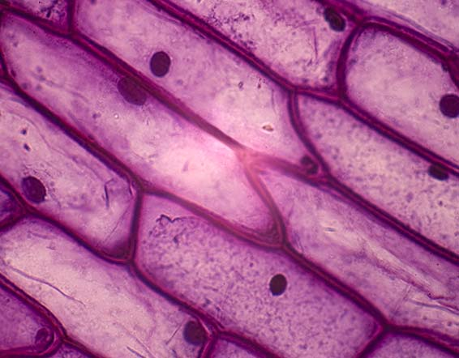
Atomic-Molecular: 100-500 Picometers (10⁻¹⁰)
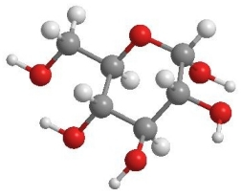

MATTER: Glucose(C₆H₁₂O₆) + 6Oxygen(O₂) → 6Carbon Dioxide(CO₂) + 6Water (H₂O)

ENERGY: chemical energy → kinetic energy + heat

Evidence of Cellular Respiration

We Breathe Out CO₂ and H₂O: As cells work, they give off carbon dioxide and water that they do not need. Carbon dioxide and water are inorganic molecules that do not have chemical energy. These molecules leave the cells and go back into the blood vessels. Eventually the H₂O and CO₂ leave our bodies. Carbon dioxide leaves when we breathe out. Water leaves when we breathe, sweat, or even as urine. What ways could you measure that animals give off H₂O and CO₂ when they breathe all from cellular respiration?
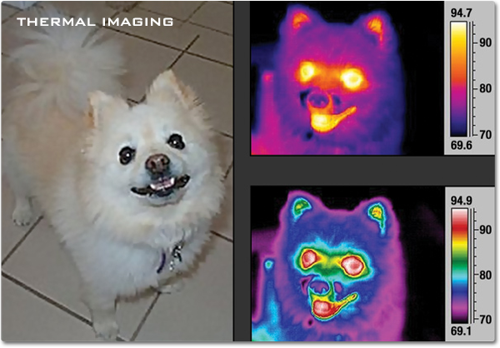
We Give Off Heat: Just like burning fuels or food changes chemical energy to heat, animal cells do a similar thing during cellular respiration. In fact, the body gives off the same amount of heat through cellular respiration that would have been given off if the food was burned. A scientist name Max Rubner proved this to be true over 100 years ago. He found that burning dog food released the same amount of energy as was released if the dog ate and metabolized the food! This also explains why our bodies stay a warm 98.6° whether it’s a warm or cold day outside!

Our “Energy Level” Changes With Food:
If animals do not get enough food and chemical energy they get tired. But when animals eat, they feel “energized”. That’s why athletes eat certain food before a big race. Our bodies react the food with oxygen, changing the chemical energy in food into motion energy we use to move around and be active..

Lesson 4: Other Examples of Decomposers

Role of this Lesson in the Unit Sequence:
Optional Activity: Fading explanations of digestion, biosynthesis and cellular respiration in the application sequences
Activity 1: Fading explanations of digestion, biosynthesis and cellular respiration in the application sequences
Activity 2: Final assessment of student progress

Duration: about 65 minutes (not including the optional activity)
Optional Activity: Decomposers in the Soil ~10 to 90 minutes
Activity 1: Other Examples of Decomposition ~45 minutes
Activity 2: Decomposers Unit Post-test ~20 minutes

Guiding Question: How do decomposers live and grow in other places?

Learning Objectives:
Students will:
- Describe systems and processes in decomposers in a hierarchy of scales, including atomic-molecular and macroscopic scales.
- Draw and explain movements of materials during decay processes.
- Identify the most abundant organic materials in decaying matter—fats, proteins, and carbohydrates—and use food labels to find out how concentrated they are in different foods and animal tissues.
- Explain the chemical changes that occur during decay, including materials being incorporated into biomass of decomposers and cellular respiration, representing the changes with molecular models and chemical equations.
- Identify forms of energy involved in decay: chemical energy, movement, and heat energy.
- Explain energy transformations during decay processes. In particular, chemical energy stored in C-C and C-H bonds of organic molecules is used to support life processes in decomposers and ultimately converted to heat.

Lesson Description:
Students finish the application sequence with the fading stage, by practicing explanations of digestion, biosynthesis and cellular respiration for other decomposers. Students retake the pretest that they took at the beginning of the unit and assess what they have learned.

Background Information:
This activity is the Fading stage of the accounts activity cycle for digestion, biosynthesis and cellular respiration. It serves as formative assessment for you—you will be able to see how well they understood the bread mold and mushroom examples—and gives students additional practice explaining examples with less support than they had for bread mold and mushrooms.

The Post-test is a summative assessment activity. You can track students’ progress by having them retake the unit pre-test as a post-test and comparing the results of the two assessments.

Lesson Materials:

For Optional Activity: Decomposers in the Soil
- National Geographic Podcast from Encyclopedia of Life: http://education.nationalgeographic.com/education/multimedia/fungi/?ar_a=1
- Forest of the Living Dead: The Longest Science Project Ever. Available as the file DrDeath_Note23.pdf on the Decomposers web page.
- Materials for laboratory activities:
  - Finding Decomposers in the Soil worksheets
  - Soil samples from different locations
  - Hand lens and/or microscopes for each group of 4 students
  - Sugar and corn starch
  - Small Ziploc containers or chamber for CO₂ probe
  - BTB or CO₂ probe

For Activity 1: Other Examples of Digestion, Biosynthesis and Cellular Respiration
- Other Examples of Decomposition worksheet per student

For Activity 2: Decomposers Unit Post-test
- Decomposers Unit Pre- and Post-test per student

Optional Activity: Decomposers in the Soil

Duration: about 10 to 90 minutes (depending on how many activities you choose to do)

Guiding Question: How do decomposers live and grow in other places?

Learning Objectives:
Students will:
- Describe systems and processes in fungi in a hierarchy of scales, including atomic-molecular and macroscopic scales.
- Draw and explain movements of materials during decay processes.
- Explain the chemical changes that occur during decay, including materials being incorporated into biomass of fungi.

Activity Description:
In this optional activity students have the opportunity to explore evidence of decomposers in soil in several different ways: a National Geographic podcast, a brief reading on decomposition of trees in the forest, and laboratory activities focusing on three different ways to find evidence of decomposers in the soil. You can choose to do any or all of these options.

Background Information:
Growing is the macroscopic manifestation of two carbon-transforming processes: digestion and biosynthesis. Since Fungi break down polymers outside their bodies, the Movement Question for digestion can be answered as atoms are moving from food to the decomposer’s hyphae cells and through the mycelium. The cells in the hyphae send out digestive enzymes that break the polymer into monomers (small organic molecules). The small monomers then can enter the cells of the hyphae and travel through the mycelium. The Movement Question for biosynthesis can be answered as atoms are moving from the hyphae to the mycelium. The Carbon Question for digestion can be answered as organic carbon in polymers are rearranged into monomers. The Carbon Question for biosynthesis can be answered as organic carbon in monomers is again rearranged into polymers. The Energy Question for both digestion and biosynthesis is that all of food polymers, monomers and biomass polymers have chemical energy.

Materials:
- National Geographic Podcast from Encyclopedia of Life: http://education.nationalgeographic.com/education/multimedia/fungi/?ar_a=1
- Forest of the Living Dead: The Longest Science Project Ever. Available as the file DrDeath_Note23.pdf on the Decomposers web page.
- Materials for laboratory activities:
  - Finding Decomposers in the Soil worksheets
  - Soil samples from different locations
  - Hand lens and/or microscopes for each group of 4 students
  - Sugar and corn starch
  - Small Ziploc containers or chamber for CO₂ probe
  - BTB or CO₂ probe

Directions:

1. Listen to and discuss the National Geographic podcast
This podcast—about 5 minutes long—involves a “walk in the forest” with scientists who investigate fungi, revealing how the visible fruiting bodies are connected to long mycelia that connect to the food sources for the fungi.

2. Read and discuss the Forest of the Living Dead
This one-page reading, written by Jenny Dauer, describes the participation of Mark Harmon, of Oregon State University’s College of Forestry, in a 200-year study of the decomposition of trees, and of the many decomposers living in dead trees.

3. Students conduct laboratory investigations of decomposers in soil
a. Collect soil samples from a variety of locations. You could ask your students to bring in samples.
b. Students can investigate these soil samples using a variety of different techniques. Each technique is on a separate page of the worksheet, so you can choose which parts of the lab you would like your students to do.
- Investigating with a hand lens. Students should be able to see mycelia of fungi as well as multicellular organisms such as worms and insects. (The multicellular organisms are mostly predators in detritus-based food webs. Their main food source is bacteria and fungi that live on dead plant materials.)
- Investigating with a microscope. Most microscopes will enable students to see single-celled organisms, but not bacteria, which have very small cells.
- Investigating CO₂ emissions from soil. Scientists investigating soil microbes often measure evidence of their respiration—carbon dioxide emissions—rather than searching for the microbes with microscopes. The lab worksheet as it is written now relies on CO₂ probes. We will investigate ways of doing this activity using BTB as the CO₂ detector.

Name:_______________________________ Teacher:_________________ Date:_________

Finding Decomposers in the Soil
Decomposers are living and growing all around us, but we often don’t notice them because the are small or hidden from sight. In this activity you will search for decomposers in the soil using three different methods: hand lenses, microscopes, and CO₂ probes to find evidence of cellular respiration.

A. Searching for decomposers with hand lenses: You will make observations of decomposers using hand lenses. For each sample, you will record the different organisms and materials you see. As you make your observations, estimate the size of the organism (macroscopic organisms you can see with your eyes or using a hand lens; microscopic organisms can only be seen using the microscope).

Materials
- Hand lens activity: Samples of soil, leaf litter, compost, hand lens, and forceps
- Microscope activity: Microscope slide, dropper, distilled water, extra cup

Observation #1: Using your hand lens

 | Write down or draw different organisms you see in the sample. | Write down or draw different materials you see in the sample.
Sample #1: _____________

Color:

Moisture (wet or dry):

Other descriptions:

Sample #2: _____________

Color:

Moisture (wet or dry):

Other descriptions:

Sample #3: _____________

Color:

Moisture (wet or dry):

Other descriptions:

B. Searching for decomposers with microscopes: You will make observations of decomposers using microscopes. For each sample, you will record the different organisms and materials you see. You will need to follow instructions for preparing microscope slides as directed by your teacher.

Procedures
- Send one partner to make your microscope slide. To do this you will need to get a slide and with tweezers, pick out a small sample of organic material to put on the slide. With a dropper, put a drop or two of the liquid surrounding the soil or compost on the slide too. Leave the dropper with the decomposition sample.
- Place the slide with the sample on the stage of the microscope. Make sure the 4x objective lens is in place. Focus on the sample. You may need to zoom in even further as you study your sample.
- Search for signs of life in the sample. When you find something, draw it in your observation table below, noting which type of sample is being examined. If you see more than one creature of the same type, note the approximate number you find next to its drawing.
- Once finished, wipe off the sample with a clean paper towel, rinse with distilled water and then you are ready to prepare another slide for observation using a different sample.

 | Write down or draw different organisms you see in the soil. | Write down or draw different materials you see in the soil.
Sample #1:

Sample #2:

Sample #3:

Some people say that soil is “just dirt”. Now that you made observations of different types of soil, what else could you say about soil?

C. Finding evidence of cellular respiration by decomposers in soil. Decomposers living in soil can take many forms. Some we can see with our eyes while many are invisible to us without microscopes. Today we are going to “feed” soil microbes two different types of food: sugar and starch, and watch how the soil microbes respond to the addition of food.

Predictions
 |  | Explain your prediction
If we measure CO₂ around a sample of soil with nothing added to it, what do you think will happen to the CO₂ levels? | ◻ increase  ◻ be the same  ◻ decrease
If we feed soil microbes sugar, what do you think will happen to CO₂ levels in the air around the microbes? | ◻ increase  ◻ be the same  ◻ decrease
If we feed soil microbes starch, what do you think will happen to CO₂ levels in the air around the microbes? | ◻ increase  ◻ be the same  ◻ decrease

Observations
Soil Type | Additive | Starting CO₂ | 5 minutes | 10 minutes | ___ minutes

Which soil sample do you think has the most decomposers? Explain why you think this using the evidence above.

Activity 1: Explaining Other Examples of Decomposition

Guiding Question: How do decomposers live and grow in other places?

Duration: 45 minutes

Activity Description:
Students choose—or you choose for them—two other examples of decomposition. Students then use the forms and procedures they used for bread mold and mushrooms to explain the carbon transforming process.

Learning Objectives:
Students will:
- Describe systems and processes in decomposers in a hierarchy of scales, including atomic-molecular and macroscopic scales.
- Draw and explain movements of materials during decay processes.
- Identify the most abundant organic materials in decaying matter—fats, proteins, and carbohydrates—and use food labels to find out how concentrated they are in different foods and animal tissues.
- Explain the chemical changes that occur during decay, including materials being incorporated into biomass of decomposers and cellular respiration, representing the changes with molecular models and chemical equations.
- Identify forms of energy involved in decay: chemical energy, movement, and heat energy.
- Explain energy transformations during decay processes. In particular, chemical energy stored in C-C and C-H bonds of organic molecules is used to support life processes in decomposers and ultimately converted to heat.

Background Information:
This activity is the Fading stage of the accounts activity cycle for digestion, biosynthesis and cellular respiration. It serves as summative assessment for you—you will be able to see how well they understood the bread mold and mushroom examples—and gives students additional practice explaining examples with less support than they had for bread mold and mushrooms.

Materials:
- Other Examples of Decomposition worksheet per student

Directions:
- FORMATIVE ASSESSMENT: Discuss general characteristics of digestion, biosynthesis and cellular respiration. See if your students can articulate a general pattern of what happens when dead plants or animals decompose:
  - The Materials Question: The food and oxygen enter the decomposer, carbon dioxide and water vapor leave the animal. Food is digested outside the decomposers, breaking polymers (large organic molecules) into monomers (small organic molecules). The monomers are absorbed by the decomposers.
  - The Carbon Question: The monomers absorbed by decomposers are used in one of two ways:
    - Biosynthesis and growth: The smaller molecules of food are reassembled as large molecules.
    - Cellular respiration to provide energy for cell functions. The atoms of food or biomass and oxygen are rearranged to make molecules of carbon dioxide and water vapor.
  - The Energy Question: Energy in high-energy C-C and C-H bonds is released as heat and light when the high-energy bonds are replaced by low-energy C-O and H-O bonds. Note that breaking bonds requires additional energy. The chemical energy is released when the low-energy C-O and H-O bonds are formed, NOT when the high-energy bonds are broken. Students should be able to articulate the patterns for each of the Three Questions at this point. You can review previous activities if this is difficult for them.

- Students explain two other examples of decomposition
Students choose two other examples from the Other Examples of Decomposition worksheet (or you can choose the examples for them) and explain them using the Process Tool.

- (Optional) Molecular models of chemical change
Students can also use molecular models to show what happens in their examples of decomposition.

Name _______________________________ Teacher _________________ Date __________

Other Examples of Decomposition Worksheet
Lesson 4, Activity 1
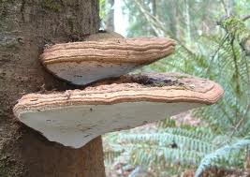
1. Choose two examples of other changes involving decomposition
- Leaves fall from trees and decay on the forest floor
- Cheese that is left in the refrigerator too long gets moldy
- Shelf fungus grows on a dead tree (see picture)
- A farmer grows clover as a cover crop, then plows it into the soil, releasing nutrients for her vegetable crops (hint: clover has lots of protein, and some decomposers can use amino acids as an energy source for cellular respiration)
- A farmer leaves wet hay in his barn, and it heats up so much that it catches on fire (for a 5-minute video, see http://www.youtube.com/watch?v=zRNCrHqD0zE)
2. Use the Process Tool and questions on the next two pages to predict what will happen in your examples.
3. (Optional): Use molecular models to show what happens inside the cells of the decomposer.

A. First example: What example did you choose? _____________________
Using the Process Tool to answer the Three Questions. Answer the Three Questions using the Process Tool below.
CHECKING YOURSELF: Does your account follow the rules?
☐ Atoms last forever: Do your answers to the questions explain how atoms can move or be rearranged into new molecules, but are not created or destroyed?
☐ Energy lasts forever: Do your answers to the questions explain how energy changes from one form to another, but there is the same amount of energy after the process as before?
BONUS: Making molecular models. Make a molecular model of the material you chose and show how it can combine with oxygen to produce the products.
BONUS: Writing the chemical equation. Use the molecular formulas and the yield sign (→) to write a balanced chemical equation for the reaction:

B. Second example: What example did you choose? _____________________
Using the Process Tool to answer the Three Questions. Answer the Three Questions using the Process Tool below.
CHECKING YOURSELF: Does your account follow the rules?
☐ Atoms last forever: Do your answers to the questions explain how atoms can move or be rearranged into new molecules, but are not created or destroyed?
☐ Energy lasts forever: Do your answers to the questions explain how energy changes from one form to another, but there is the same amount of energy after the process as before?

BONUS: Making molecular models. Make a molecular model of the material you chose and show how it can combine with oxygen to produce the products.

BONUS: Writing the chemical equation. Use the molecular formulas and the yield sign (→) to write a balanced chemical equation for the reaction:

Name _______________________________ Teacher _________________ Date __________

Grading Other Examples of Decompostion Worksheet
Lesson 4, Activity 1
It is reasonable to grade this assignment. General characteristics of correct responses are in bold blue italics.
1. Choose two examples of other changes involving decomposition
- Leaves fall from trees and decay on the forest floor
- Cheese that is left in the refrigerator too long gets moldy
- Shelf fungus grows on a dead tree (see picture)
- A farmer grows clover as a cover crop, then plows it into the soil, releasing nutrients for her vegetable crops (hint: clover has lots of protein, and some decomposers can use amino acids as an energy source for cellular respiration)
- A farmer leaves wet hay in his barn, and it heats up so much that it catches on fire (for a 5-minute video, see http://www.youtube.com/watch?v=zRNCrHqD0zE)
2. Use the Process Tool and questions on the next two pages to predict what will happen in your examples.
3. (Optional): Use molecular models to show what happens inside the cells of the decomposer.
For Growing (digestion and biosynthesis combined):
Atoms are moving from food
Atoms are moving into the cells of decomposers (and through the hyphae of fungi)

Carbon atoms are in polymers in food
Carbon atoms are broken into monomers and reassembled as polymers

Chemical energy
Chemical energy

For cell functioning (cellular respiration):
Glucose or other food molecules inside the decomposer
From air (oxygen) to animals
To air from decomposer (CO₂)
To water (H₂O)

Glucose, C₆H₁₂O₆
Carbon dioxide
Water

CHECKING YOURSELF: Does you account follow the rules?
Chemical energy
Motion energy, heat energy
Check to be sure that students separate matter and energy in their accounts
BONUS: Making molecular models. Make a molecular model of the material you chose and show how it can combine with oxygen to produce the products.
Some students may be able to make molecular models and write balanced equations, but we do not suggest this as a requirement for all students.

Activity 2: Decomposers Unit Posttest

Guiding Question:
What have students learned about decomposers and the process of decomposition?

Duration: 20 minutes

Activity Description:
Students retake the pretest that they took at the beginning of the unit and assess what they have learned.

Learning Objectives:
- Take a test that assesses most key learning objectives for the unit.

Background Information:
The Post-test is a summative assessment activity. You can track students’ progress by having them retake the unit pre-test as a post-test and comparing the results of the two assessments.

Materials:
- Decomposers Unit Pre- and Post-test per student

Directions:

- Pass out the unit post-test to each student.
They should be able to answer the questions correctly, so it is reasonable to grade them at this point.

Grading the Decomposers unit Posttest

It is reasonable to grade the posttest as a summative assessment. Level 4 (correct) responses to the questions are in blue bold italics below. There are also comments connecting the questions to unit activities in blue italics.

1. A tree falls and gradually decays while it is sitting on the ground. Answer these questions about what is happening to the materials and energy in the tree as it decays.

Do you think that materials (solids, liquids, or gases) are going into the decaying tree? (circle one answer below)  Yes No I’m not sure | Do you think that energy is going into the decaying tree? (circle one answer below)  Yes No I’m not sure  Any of these answers could be justified. Light and heat energy are being absorbed by the tree from its surroundings, but they do not play a direct role in the decay process
What materials do you think are going into the decaying tree?  Oxygen is the key material that is essential for the decay process. Other materials such as water help create the conditions for decay, but do not participate directly in the process. | What form(s) of energy do you think are going into the decaying tree? Light and heat energy are being absorbed by the tree from its surroundings, but they do not play a direct role in the decay process.
Do you think that materials (solids, liquids, or gases) are coming out of the decaying tree? (circle one answer below)  Yes No I’m not sure | Do you think that energy is coming out of the decaying tree? (circle one answer below)  Yes No I’m not sure
What materials do you think are coming out of the decaying tree?  Carbon dioxide, water, and soil minerals. | What form(s) of energy do you think are coming out of the decaying tree?  Heat energy or thermal energy..
How do you think that materials are changing inside the decaying tree?  The polymers (such as cellulose and proteins) that the tree is made of are being digested by decomposers, who use the resulting monomers for biosynthesis and cellular respiration. The primary long term change is through cellular respiration, in which combines tree materials with O₂ to produce CO₂ and water. | How do you think that energy is changing inside the decaying tree?  Chemical energy in tree materials is being transformed to energy for cell functions, then ultimately to heat energy.
What are you not sure about in your answers? Explain what you need to know to answer these questions better.
Students who successfully identify things that the don’t know have taken a big step toward successful learning. Note your students’ questions and think about how they can be answered in future units.

2. A loaf of bread was left alone for 2 weeks. Three different kinds of mold grew on it. Assuming the bread did not dry out, which of the following is a reasonable prediction of the weight of the bread and mold after the 2-week period?
a. The mass has increased, because the mold has grown.
b. The mass remains the same as the mold converts bread into biomass.
c. The mass decreases as the growing mold converts bread into energy.
d. The mass decreases as the mold converts bread into biomass and gases.

Explain your reasoning. How does decay affect the combined weight of the bread and the mold?
Level 4 responses recognize that there are multiple processes occurring as the mold grows on bread, and that only some of the mass of the bread will be incorporated into the mold biomass. The rest will be lost to the air in the form of gaseous waste (CO₂ and water vapor) as a result of cellular respiration.

3. When a tree is alive it has energy stored in its living parts (roots, trunk, branches and green leaves). When the tree dies all the parts are still there (including fallen brown leaves). How much of the energy stored in the living tree is still there in the dead tree?
a. ALL of the energy
b. MOST of the energy
c. SOME of the energy
d. A LITTLE of the energy
e. NONE of the energy
What kinds of energy are stored in the dead tree (if any)? How are they connected to the energy in the living tree?
Level 4 responses will recognize that chemical energy is stored in the (C-C and C-H) bonds of organic substances that make up the tree, and that this is true whether the tree is alive or dead. Small amounts of energy are stored in other materials such as ATP, so a choice of “most of the energy” could be justified.
What happens to the energy stored in the tree when the dead tree decays?
The chemical energy stored in the tree is transformed into energy for cellular functioning and heat energy and lost to the environment.

4. A potato is left outside and gradually decays. One of the main materials in the potato is the starch, which is made of many sugar molecules (C₆H₁₂O₆) bonded together. What happens to the atoms in starch molecules as the potato decays? Circle True (T) or False (F) for each option.
T F Some of the atoms are changed into soil nutrients: nitrogen and phosphorus.
T F Some of the atoms are used up by decomposers and no longer exist.
T F Some of the atoms go into the air in carbon dioxide.
T F Some of the atoms are turned into energy by decomposers.
T F Some of the atoms go into the air in water.
Explain the pattern in your answers. What happens to the atoms in the starch when the potato decays?

Students who understand the Rules to Follow in the Three Questions will know that the three false statements MUST be false, even if they know nothing about specifically what happens when potatoes decay, because they violate the Rules to Follow in the Three Questions. Developing this sense of necessity about conservation of matter and energy is a primary goal of all Carbon TIME units.

5. Answer these true-false questions:
True False Carbon is a kind of atom.
True False Carbon is a kind of molecule.
True False There is carbon in a mushroom.
True False There is carbon in the soil of a forest.
True False There is carbon in the air.

This statement simplifies chemists’ understanding of the nature of chemical potential energy. It would be more accurate to say that chemical potential energy is transformed to light and molecular motion (thermal energy) when organic materials are oxidized. In the Earth’s oxidizing atmosphere, however, reduced materials that can be oxidized are the limiting reactants in most environments, and C-C and C-H bonds signal the presence of reduced carbon and hydrogen.
We also note that the process depicted on the Cell respiration.avi file is not a completely accurate representation of cellular respiration as it actually occurs. Cellular respiration is a multi-stage process which also includes 6 H₂O molecules as reactants. In the products, all of the oxygen atoms from O₂ actually end up in H₂O. For more details see http://dqc.crcstl.msu.edu/respiration.

